Harold W. & Jessie L. Freeman Foundation - established 2011
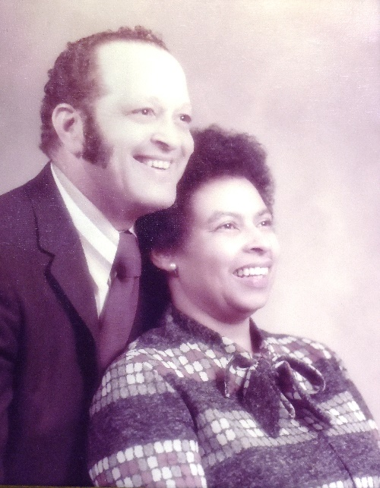

Harold Freeman is clear about his life purpose: “I’m not rich. But I’m rich in God’s blessings. I have enough. The truth is, these days I give away more money than I take in. This is what God wants me to do.”

Harold credits his late wife Jessie with instilling a passion for charitable volunteerism in him. “Jessie loved to help the children of the world. We dreamed of retiring together and spending the rest of our lives immersed in volunteer work.”

After a prolonged battle with cancer, Jessie lost. A despondent Harold immersed himself in volunteer work, and for 12 years he was a faithful volunteer with the American Cancer Society.

Several months after Jessie passed away, Harold received a check for $483,000. Harold was stunned at the size of Jessie’s pension annuity death benefit check. Harold pondered what to do with the money, and over time it was revealed to him: “God spoke to me and it became clear that I should share what God had given to me. I found a financial advisor and told him I wanted this money to go to charity.”

Today, the Harold W. and Jessie L. Freeman Foundation at the Chester County Community Foundation focuses on highly effective Christian charities. All have a focus on basic needs such as food, clothing, shelter and healthcare. Education and social justice are also underlying core values.

Harold’s primary goal for the Freeman Foundation has always been to do charitable good works in Jessie’s memory. Harold explains, “God took Jessie from me, and left me here on Earth. So, my aim is to honor Jessie’s life while I am still here, and when I’m gone. I don’t want Jessie’s money or her memory to wither and die. I want the funds to be used to perpetuate Jessie’s memory and do the charitable good works she was so devoted to.”

