Sweet Jane’s Wish Foundation Awards Scholarships to Downingtown East and West Ice Hockey Players

Downingtown, PA— May 14th — Sweet Jane’s Wish (SJW) Foundation is happy to announce that Seniors, Logan James, of Downingtown West and, Anderson Frain, of Downingtown East have been selected as the winners of the annual SJW scholarship fund. Four students are selected each school year from the tennis and ice hockey teams by the SJW Foundation. Logan and Andy join our Fall scholarship recipients, Gianna Brown and Twisha Dudgundi. SJW Foundation is a fund of the Chester County Community Foundation and honors the memory of Jane Gerlach Booge who tragically lost her battle with breast cancer at age 47. Jane attended Downingtown High School and was a member of the tennis team. Her quiet confidence and positive attitude took her to numerous championship matches including districts and state competitions. Jane was well known for her compassion and friendship to many.
SJW Foundation honors students such as Logan and Andy who share Jane’s qualities of determination, resilience, camaraderie and have a love of tennis or ice hockey. Logan and Andy demonstrate these qualities by consistent dedication to their sport and team members.
“I have no regrets.” That’s how Logan James describes his years on the ice. Logan is an athletic kid with a history of playing football as his family does. He, however, had a different dream. He wanted to play ice hockey. His freshman year he let the coach, and his family know he planned to switch sports. Although he met some expected resistance, he was determined to focus his time and attention on learning ice hockey from the basic skill of learning to skate prior to tryouts, to understanding the game of ice hockey itself. His persistence paid off and he made the team. By his second year, he won an award for dedication, perseverance, and drive. Logan was described by the coach as the “true leader of the team, seeking advice for not only himself, but for the entire team prior to games. He also encourages and motivates his teammates even during tough losses.” We all set goals for ourselves. To reach them you need a plan. You need to know where you are today and where you want to end up. In between is the hard work, the dedication, sweat equity, and motivation required to reach your goal. Logan decided he wanted to play hockey despite opposition and pursued it with passion and determination. He never gave up. In his own words, “I have learned being true to yourself and putting everything you have into your goals can yield immeasurable life rewards.” So true!
Anderson Frain first learned to skate at four years old. Within a year he was lacing up his skates to join the Dyna-Mites ice hockey team, the first of many teams he would join and the beginning of logging many hours on the ice. He loves the thrill of split-second decisions, the speed required to follow them through and the joy of scoring a goal against worthy opponents.
Having played hockey most of his life, many of Andy’s closest friends have been on ice hockey teams. However, he recognizes that there are times you play with people you may not choose as friends but that they still are valuable to work with. He acknowledges that that skill will be useful as he moves forward in life. Andy, having read about Jane Booge, and how “she faced cancer the way she faced tennis matches quietly and confidently intending to dismantle her opponent”, he recognized that he played hockey and approached life this way. His coach agreed, stating that he was “even keeled, led by action and had a great attitude”. Andy’s determination and enthusiasm for hockey while requiring split-second decisions yet managing to stay calm has made him an excellent teammate and will guide him well in the future.
Logan and Andy are talented ice hockey players who are passionate about the game. It’s clear that the game is just a part of what they have learned along the way. Both boys are leaders and their enthusiasm for the game is evident. They’ve learned to work hard and never give up. These lessons have developed skills and character which will serve them throughout their lives.
We are honored to have Logan and Andy join the forty-four previous recipients of this $6,000 award. To date SJW Foundation has awarded $171,000 in scholarships to Downingtown East and West High School Seniors who have participated in the student tennis and ice hockey programs and are furthering their education at a University, College, or Trade School.
Due to the success of the annual golf outing and the amazing generosity of supporters, the SJW Foundation is also able to support the Living Beyond Breast Cancer (LBBC) organization and the Chester County Hospital Foundation, SHiNE with a yearly donation. The SJW Foundation has donated more than $33,000 to support local families experiencing financial crisis, due to the additional costs incurred while fighting breast cancer.
SJW Foundation scholarships are funded by an annual golf outing, dinner, and auction and by generous donations from our community. Please join us on Monday, September 8, 2025, for our 14th annual golf outing. The outing will be held at the Downingtown Country Club, in Downingtown, PA. Please look online for more information at www.sweetjaneswish.com and follow us on Facebook. We hope you join us for a wonderful day that supports our community!
For more information, press only:
Alexandra Grigson
(484) 919-5699
Agrigson@gmail.com
For more information on the Sweet Jane’s Wish Foundation:
www.sweetjaneswish.com and follow us on Facebook.
Downingtown West Picture from left:
Sister, Siena James, parent, Donna James, scholarship recipient, Logan James, coach, John Hyland, parent, Sean James
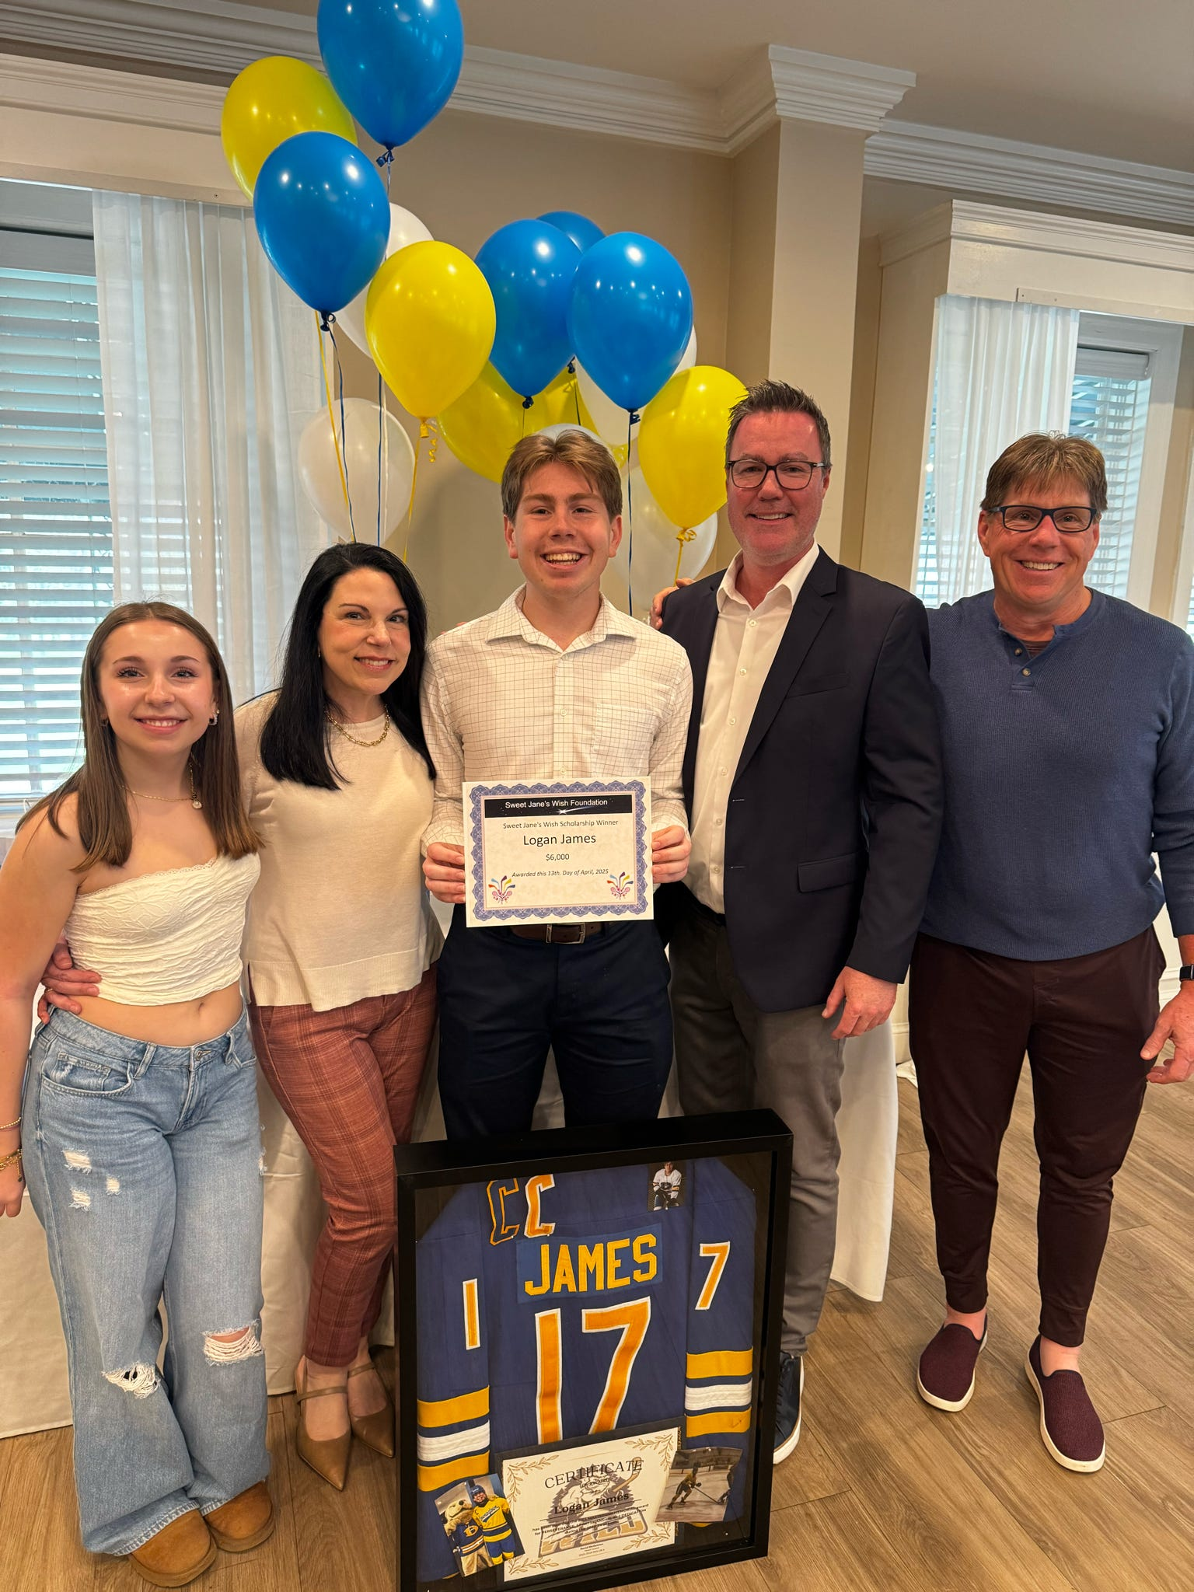
Downingtown East Picture from left:
Parent, Diane Frain, scholarship recipient, Anderson Frain, Parent, Ted Frain, 2nd row coach, Mark Bobko
