Sweet Jane’s Wish Foundation Awards Scholarships to Downingtown East and West Tennis Players

Downingtown, PA— November 14 — Sweet Jane’s Wish (SJW) Foundation is happy to announce Seniors, Gianna Brown, of Downingtown West and, Twisha Dudgundi of Downingtown East have been selected as the winners of the annual SJW scholarship fund. Four students are selected each school year from the tennis and ice hockey teams by the SJW Foundation. Gianna and Twisha join our Spring scholarship recipients, Nick Geanopulos and Joseph Butler. SJW Foundation is a fund of the Chester County Community Foundation and honors the memory of Jane Gerlach Booge who tragically lost her battle with breast cancer at age 47. Jane attended Downingtown High School and was a member of the tennis team. Her quiet confidence and positive attitude took her to numerous championship matches including districts and state competitions. Jane was well known for her compassion and friendship to many.
SJW Foundation honors students such as Gianna and Twisha who share Jane’s qualities of determination, resilience, camaraderie and have a love of tennis or ice hockey. Gianna and Twisha demonstrate these qualities by consistent dedication to their sport and team members.
Gianna Brown always loved playing tennis. But it wasn’t until she coached beginners that she recognized her own potential as a leader and motivator on the court. Gianna decided to teach eight-year-olds tennis this past summer. It sounded fun but she had no idea how invested she would become in her students. It was more than teaching them where to stand, or how to hold the racket. It required patience, listening and of course encouraging them. She realized while she was teaching that she had skills like empathy, leadership and being supportive that she could draw on in other areas of her life. Gianna found as team captain; those same skills were invaluable. She encouraged her teammates in tough matches, offered support when they sought help to improve their game and looked out for their wellbeing. Every new challenge offers us the opportunity to learn something new about our own abilities. It’s amazing what Gianna was able to learn about herself while teaching others.
Everyone comes to a sport for different reasons. Some join to meet new people or be with established friends, to try something new or because the minute they step on the court, they feel a focus and joy that they haven’t found anywhere else. It was like that for Twisha Dudgundi. When she entered the court, everything else melted away. There was one goal and a singular focus that brought out the competitor in her. She loved being on the court. She loved the challenge, the team, and striving for more. It taught her to work hard to win and work harder if she lost. As the team captain, Twisha was supportive and a mentor to her teammates. Her coach appreciated Twisha’s enthusiasm for the game, talent and willingness to work with her teammates to build their skills. In Twisha’s own words, “Tennis gave me the strength to overcome my fears and in return, I’ve given it everything I have.” Clearly, she has and will benefit from drawing on that strength in her future endeavors.
Gianna and Twisha are talented tennis players who are passionate about the game. It’s clear that the game is just a part of what they have learned along the way. Both girls are leaders and their enthusiasm for the game is evident. They’ve learned to work hard and never give up. These lessons have developed skills and character which will serve them well throughout their lives.
We are honored to have Gianna and Twisha join the previous forty-two recipients of this $5,500 award. To date SJW Foundation has awarded $147,000 in scholarships to Downingtown East and West High School Seniors who have participated in the student tennis and ice hockey programs and are furthering their education at a University, College, or Trade School.
Due to the success of the annual golf outing and the amazing generosity of supporters, the SJW Foundation is also able to support the Living Beyond Breast Cancer (LBBC) organization and the Chester County Hospital Foundation, SHiNE with a yearly donation. The SJW Foundation has donated more than $32,000 to support local families experiencing financial crisis, due to the additional costs incurred while fighting breast cancer.
SJW Foundation scholarships are funded by an annual golf outing, dinner, and auction and by generous donations from our community. Please join us on Monday, September 8, 2025, for our 14th annual golf outing. The outing will be held at the Downingtown Country Club, in Downingtown, PA. Please look online for more information at www.sweetjaneswish.com and follow us on Facebook. We hope you join us for a wonderful day that supports our community!
For more information, press only:
Alexandra Grigson
(484) 919-5699
Agrigson@gmail.com
For more information on the Sweet Jane’s Wish Foundation:
www.sweetjaneswish.com and follow us on Facebook.

Downingtown West Picture from left:
Coach, Justin DePietropaolo, scholarship recipient, Gianna Brown, parent, Laura Brown, parent, Zach Brown
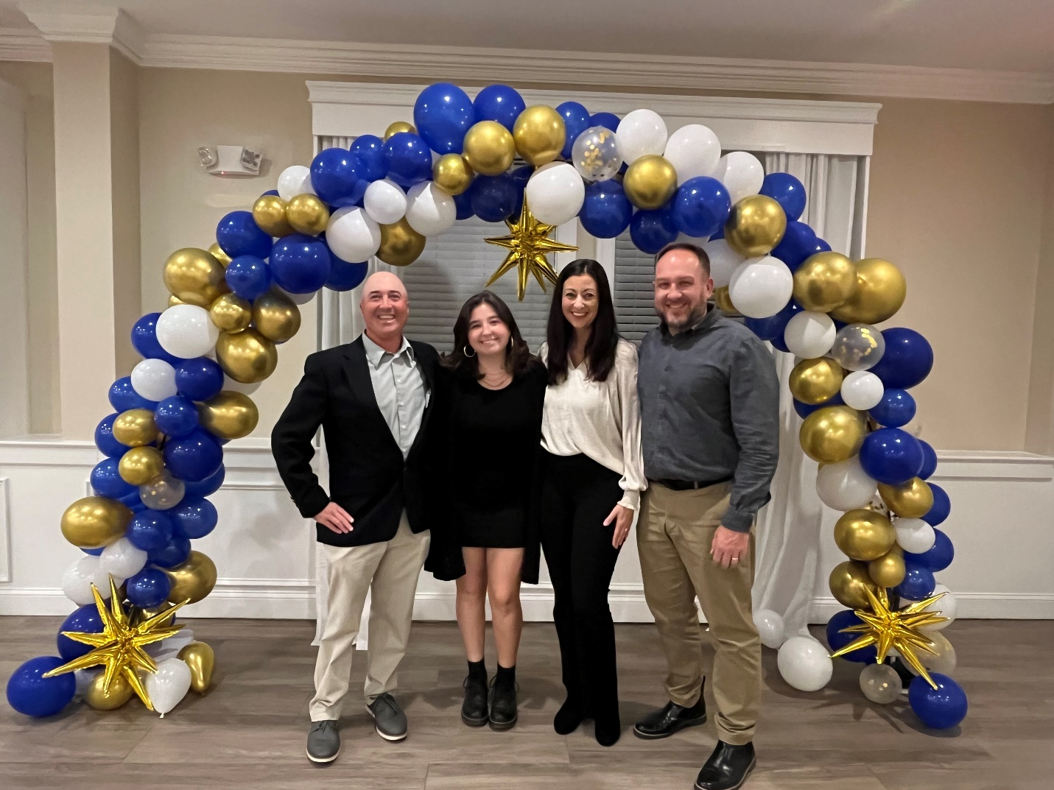

Downingtown East Picture from left:
Coach, Steph Vo, parent, Srinivas Dudgundi, scholarship recipient, Twisha Dudgundi, coach, Lisa Sheldon
