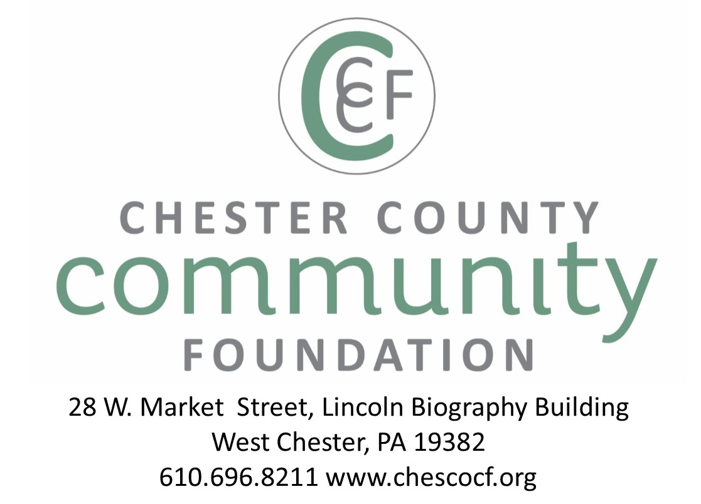

ENDOWED, QUASI-ENDOWED AND PROVISIONAL DONOR-ADVISED FUND AGREEMENT

BETWEEN THE CHESTER COUNTY COMMUNITY FOUNDATION

AND xxx

THIS AGREEMENT, made and entered into by and between THE CHESTER COUNTY COMMUNITY FOUNDATION, INC. (the “Foundation”), and XXX (hereinafter referred to as the “Founding Contributors”),

WITNESSETH:

WHEREAS the Founding Contributors desire to create a permanently endowed, donor-advised fund (complemented by a provisional fund component and/or a quasi-endowed component) within the Chester County Community Foundation; and

WHEREAS, the Foundation is a non-profit Pennsylvania corporation exempt from taxation under Internal Revenue Code (“Code”) section 501(c)(3), a public charity described in section 170(b)(1)(A)(vi) of the Code, and accordingly an appropriate institution within which to establish such a fund; and

WHEREAS, the Foundation is willing and able to create this fund, subject to the terms and conditions hereof;

NOW THEREFORE, the parties agree as follows:

- NAME OF THE FUND. There is hereby established in the Foundation, and as a part thereof, a fund named the “xxx” (hereinafter referred to as the “Fund”), designated to receive gifts, in whatever form of money or property, and to administer the same.

2. PURPOSE. The purpose of this Fund shall be to make grant distributions for charitable purposes to nonprofit organizations and other charitable causes as recommended by the Fund Advisors and approved by the Board of the Community Foundation. (Further detail on donor intent can be included in Attachment B.)

3. GIFTS. The Founding Contributor/s will transfer irrevocably to the Foundation assets to establish the Fund. Subject to the right of the Foundation to reject any particular gift, any person whether an individual, corporation, trust, estate or organization (hereinafter referred to as “Donor”) may make additional gifts to the Foundation for the purposes of the Fund by a transfer to the Foundation of property acceptable to the Foundation in whole or in part for the Fund. All such gifts, bequests and devises to this Fund shall be irrevocable once accepted by the Foundation.

Upon gifting, donors will instruct the Foundation as to whether the contribution will be added to the endowed component, the quasi-endowed component, or the provisional component of this Fund. Absent such an instruction, the contribution once accepted by the Foundation will be added to the endowed fund.
4. DISTRIBUTION.

- The Advisor/s for this Fund are xxxxx. The Fund Advisors make charitable distribution requests to the Foundation and receive financial reports on the Fund.

- The Fund Advisor/s may designate in writing a Successor Advisor, to advise the Foundation in the event of withdrawal, incapacity or death of the Fund Advisor.

- In the event that no one advises the Foundation on the distribution of the Fund for three (3) consecutive years, the Foundation may deem that no one has an interest in advising with respect to the Fund, and may terminate such rights after written notice to the last known address of the last designated Fund Advisor. In that case, the Board of Directors of the Foundation will assume responsibility for making grant distributions in alignment with the Purpose as outlined herein and from a review of any grant history.

(d.1.) Within 12 months following the end of the Foundation’s fiscal year (6/30), up to 5% of the year-end asset value of the Endowed Component of this Fund may be distributed to fulfill the purpose of this Fund.

(d.2.) Within 12 months following the end of the Foundation’s fiscal year (6/30), up to 20% of the year-end asset value of the Quasi-Endowed Component of this Fund may be distributed to fulfill the purpose of this Fund.

(d.3.) Portions up to 100% of the Provisional Component of this Fund may be granted out at any time.

(e) Per IRS regulations, donor-advised funds cannot be used to pay for dues, memberships, benefit tickets, golf tournaments, irrevocable pledges or tithes, or to pay for other events or activities for which Fund Advisors, related parties, or others will receive personal benefits.

(f) Per IRS regulations, donor-advised funds cannot be used to make grants to individuals, nor grants to entities to benefit a specified individual.

(g) Per IRS regulations, donor-advised funds cannot be used to make grants, loans, compensation or similar payments to donors, fund advisors, or related parties.

(h) Both the principal and interest of the Fund must be committed, granted or expended for purposes described in Code Section 170(c)(2)(b) to organizations described in Code Sections 509(a)(1), (2), (3).

(i) If any gifts to the Foundation for the purposes of the Fund are received and accepted subject to a Donor’s conditions or restrictions as to the use of the gift or income therefrom, said conditions or restrictions will be honored, subject, however, to the authority of the Foundation’s Board of Directors (hereinafter “the Board”) to vary the terms of any gift if continued adherence to any condition or restriction is in the judgment of the Foundation’s Board of Directors unnecessary, incapable of fulfillment or inconsistent with the charitable needs of the community served by the Foundation. No distribution shall be made from the Fund to any individual or entity if such distribution will, in the judgment of the Foundation, endanger the Foundation’s Code section 501(c)(3) status. The Board of the Foundation retains sole discretion regarding gifts and distributions.

5. ADMINISTRATIVE PROVISIONS. Notwithstanding anything herein to the contrary, the Foundation shall hold the Fund, and all contributions to the Fund, subject to the provisions of the applicable Commonwealth of Pennsylvania laws and the Foundation’s Articles of Incorporation and Bylaws. The Board shall monitor the distribution of the Fund, and shall have all powers of modification and removal specified in United States Treasury Regulations Section 1.170A-9(e)(11)(v)(b).

The Board agrees to provide the Founding Contributor/s, upon request, a copy of the annual audit of the finances of the Foundation as reported upon by independent certified public accountants.

The Foundation will also report to the Fund Advisor/s the status of the Fund including contributions received, fees charged, earnings, and distributions made during the fiscal year.

6. CONDITIONS FOR ACCEPTANCE OF FUNDS. Founding Contributor/s agree and acknowledge that the establishment of the Fund herein created is made in recognition of, and subject to, the terms and conditions of the Articles of Incorporation and By-laws of the Foundation as from time to time amended, and that the Fund shall at all times be subject to such terms and conditions, including but not by way of limitation, provisions for:
(a) Presumption of Donor’s intent;
(b) Variance from Donor’s direction;
(c) Amendments

7. CONTINUITY. The Fund shall continue during the lifetime of the Founding Contributor/s, and for perpetuity under the direction of named successor Fund Advisors so long as assets are available and the purposes of the Fund can be served by their continuation. If the Fund is terminated, the Community Foundation shall devote any remaining assets exclusively for charitable purposes that:

(a) are within the scope of the charitable purposes of the Foundation Articles of Incorporation; &

(b) most nearly approximate, in the good faith opinion of the Board, the original purpose of this Fund.

8. NOT A SEPARATE TRUST. The Fund shall be a component part of the Foundation. All money and property in the Fund shall be held as general assets of the Foundation and not segregated as trust property of a separate trust; provided that for purposes of determining the share of the Foundation’s earnings allocable to the Fund and the value of the principal of the Fund, the interest of the Fund in the general assets of the Foundation shall be a percentage determined by dividing the gifts to the Fund by the then value of the total assets of the Foundation, such percentage interest being subject to adjustment at the time of each addition to or reduction of the assets of the Foundation.

9. ACCOUNTING. The receipts and disbursements of this Fund shall be accounted for separately and apart from those of other gifts to the Foundation. The Foundation shall provide for an annual independent audit of this and all other Funds under management.

10. INVESTMENT OF FUNDS. The Foundation shall have all powers necessary, or in its sole discretion desirable, to carry out the purposes of the Fund, including, but not limited to, the power to retain, invest and reinvest the assets of the Fund.

11. COSTS OF THE FUND. It is understood and agreed that the Foundation is to be paid for its services hereunder and that said compensation is to be paid from the assets of the Fund. A fee schedule is included as Attachment A. The Board of Directors at its discretion may revise the attached fee schedule pursuant to notice of such fee revision provided to the Fund Advisors. The compensation of the Foundation is to be calculated and paid prior to any distributions made pursuant to paragraph 4 above. Any investment fees that may be charged by the Fund’s investment manager(s) will be deducted prior to reporting the net earnings of the Fund.

IN WITNESS WHEREOF, the Founding Contributor/s execute this Agreement and the Foundation has caused this Agreement to be approved by its Board of Directors and to be executed by a duly authorized officer, all as of the day and year written.

FOUNDING CONTRIBUTOR/S:

Name:_______________________________Name:__________________________________

CHESTER COUNTY COMMUNITY FOUNDATION, INC.: EIN 23-2773822

President/CEO: _______________________
Date:___________________




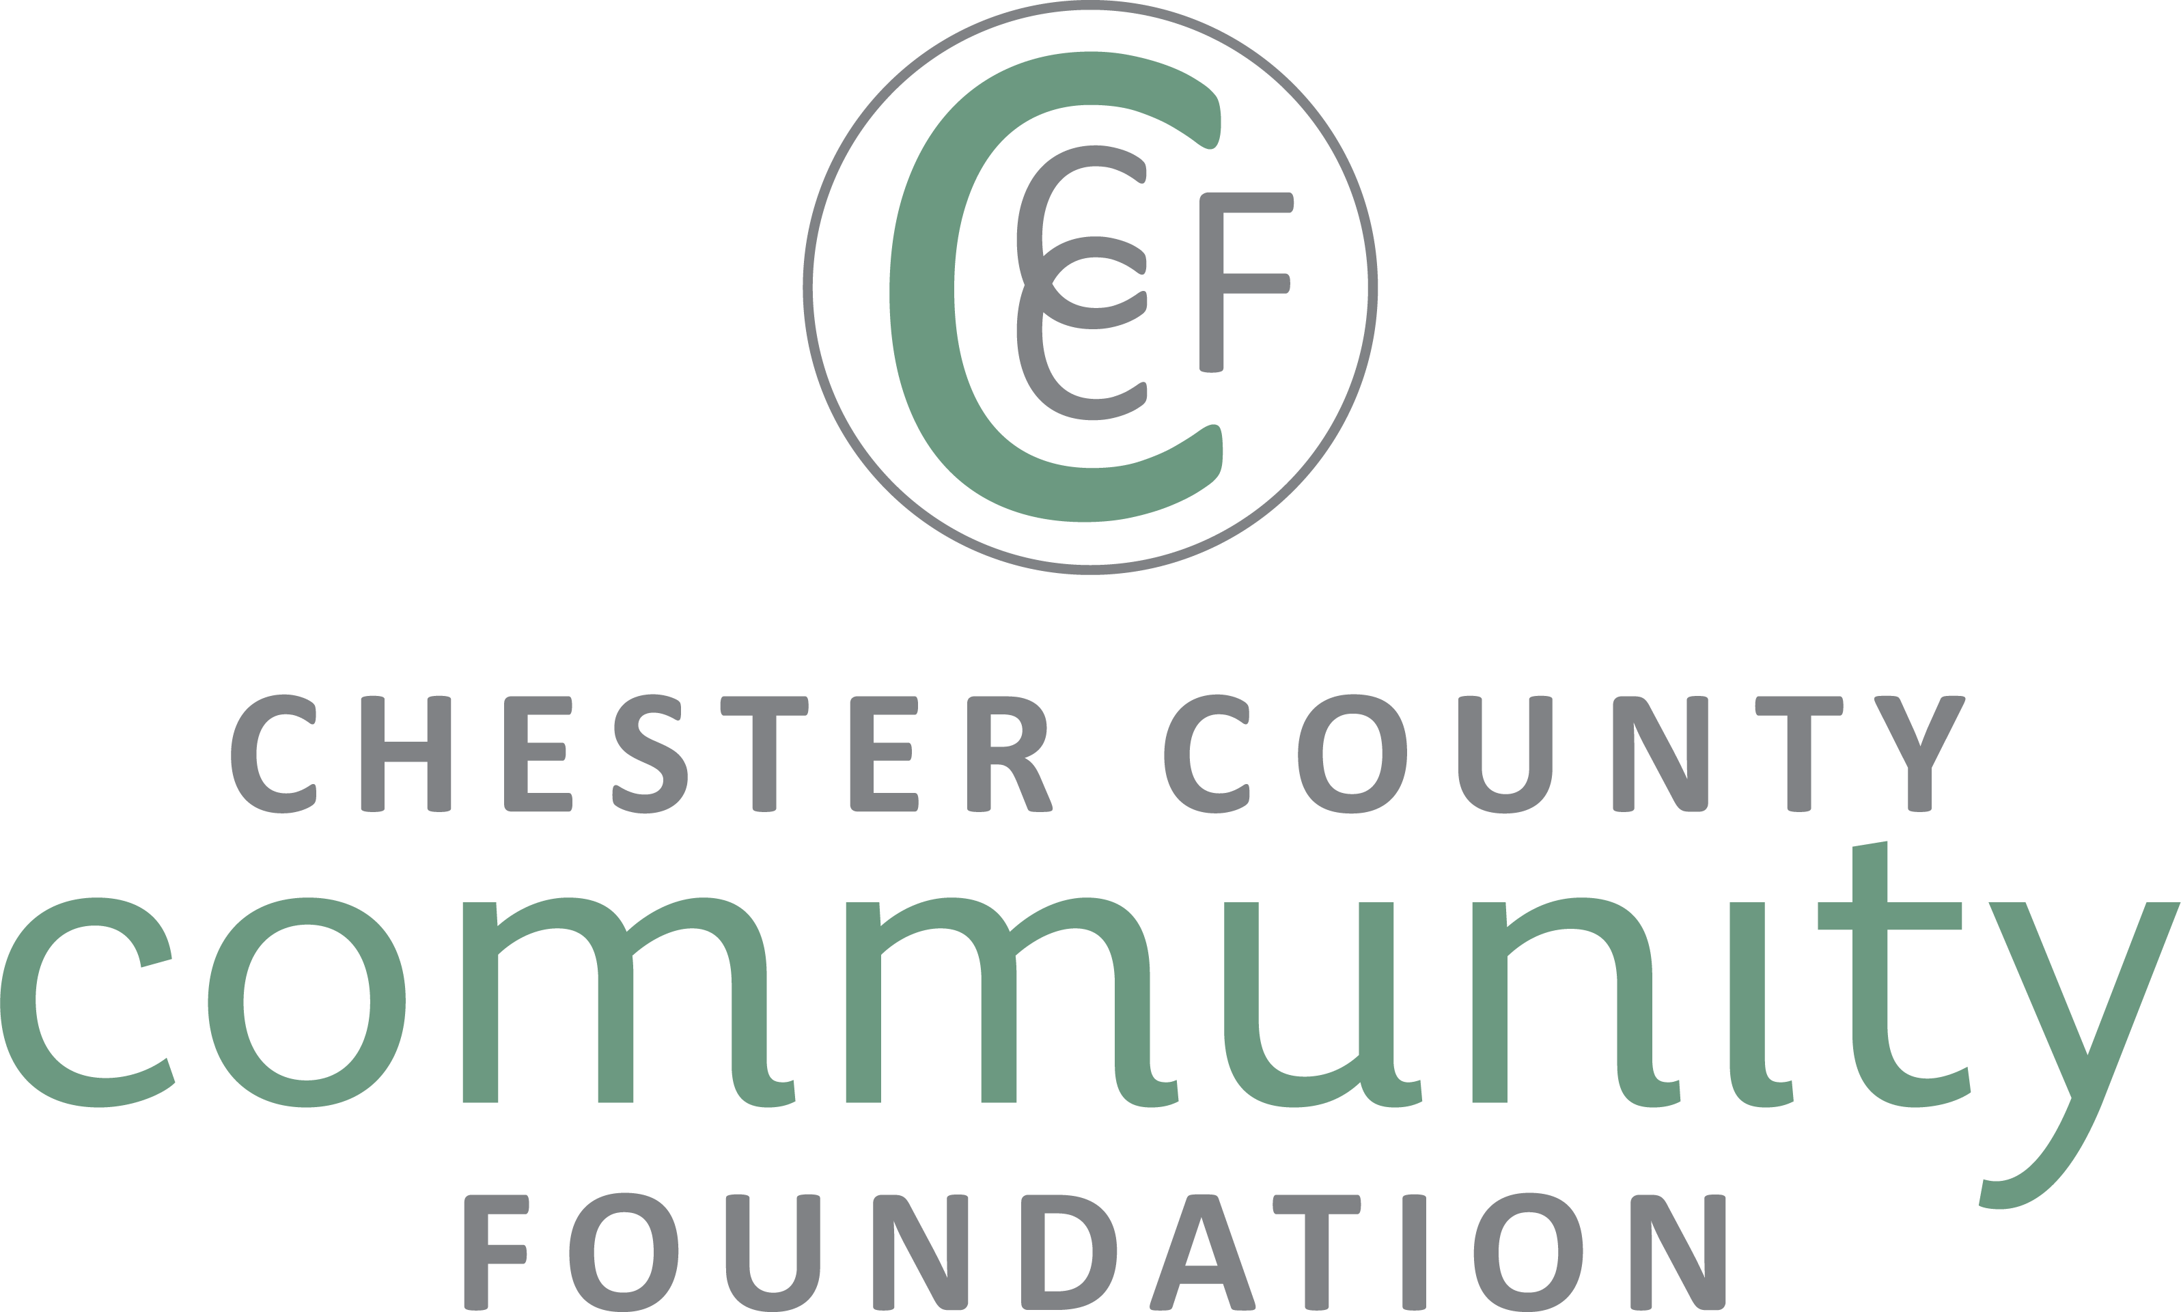

ATTACHMENT A:
FUND FEES & FINANCIAL POLICIES

It is understood and agreed that the Foundation is to be paid for its services and that compensation is to be paid from the assets of the Fund, per the schedule noted below. The Board of Directors at its discretion may revise this schedule, giving notice of such revision to Fund Advisors.
 |  | ENDOWED | QUASI-ENDOWED | PROVISIONAL
EARNINGS |  | Earn pro-rated share of invested returns, posted monthly |  | Short-term;  no returns
SPENDING POLICY (annual grant awards, based on June 30 FYE balance) |  | Up to 5% | Up to 20% | Up to 100%
ANNUAL FEES
DONOR ADVISED FUND  FIELD OF INTEREST FUND  NONPROFIT ENDOWMENT FUND | Fund balance < $1M | 1.00% |  | 2.5% fee
 | Fund balance $1 - $5M | .75% |  | n/a
 | Fund balance > $5M | .50% |  | n/a
TESTAMENTARY FUND  With initial endowed, quasi &/or provisional components; long-term focus on endowed | Fund balance < $1M | 1.00%
 | Fund balance $1 - $5M | .75%
 | Fund balance > $5M | .50%
FISCAL AGENCY FUND (2 year max) | n/a |  |  | 15.0% fee
SCHOLARSHIP FUND | 2.5% fee
MAJOR FUNDRAISING EVENTS* | 10% fee, calculated as each contribution is received
CCCF ADMINISTERED FUNDS | 2.0% fee
FEE COMPUTATION | Annual fee, charged monthly based on balance |  |  | One-time fee, charged as each gift is donated
SEPARATELY MANAGED  MEDALLION FUNDS | CCCF may add a .25% annual fee if significant administrative time is incurred |  |  | n/a
MINIMUMS
MINIMUM FOR SEPARATELY  MANAGED MEDALLION FUND | $250,000 with intent to reach  $1M within 5 years |  |  | n/a
MINIMUM FUND BALANCE TO AWARD GRANTS/SCHOLARSHIPS | $25,000 |  |  | n/a
MININUM SCHOLARSHIP AWARD | $500 is the minimum scholarship award.
MINIMUM GRANT AWARD | $250 is the recommended minimum grant award.
*FUNDRAISING EVENT  LEGACY POLICY | As the Community Foundation focuses on long-term legacy philanthropy, at least 25% of each fundraising event's proceeds must be allocated to an endowed or quasi-endowed fund prior to grant/scholarship awards.
FOUNDING CONTRIBUTOR/S:
Name:_______________________________Name:__________________________________

CHESTER COUNTY COMMUNITY FOUNDATION, INC.: EIN 23-2773822

President/CEO: _______________________ Date:__________________

ATTACHMENT B: PURPOSE OF THE FUND: DONOR INTENT

The Founding Contributor can make grants to any bona fide charitable causes as desires throughout their lifetime. A grant history will develop that the Community Foundation Grants Committee will emulate over time. The Grants Committee will take into consideration the constituents served, the core values of the charitable organization, the size and scale of the nonprofit organization, and other desires outlined by the Founding Contributor.

These General Parameters may help the Founding Contributor describe what types of nonprofit charities they wish to fund for perpetuity:

Types:
Causes/issues/fields of interest: arts, culture, education, environment, health, human service, social service, religion
Target market populations served

Purpose of Grant Support:
General operating support, Capacity building, Capital, Endowment

Size of nonprofit charity:
Emerging, Grassroots, Mid-sized, Large

Geographic service area:
Borough/town
Chester County: north, south, east, west, central, countywide
Philadelphia region
Pennsylvania
PA-NJ-DE
East Coast, etc.
Nationwide
International (with U.S. 501c3)

Nonprofit Charity | Field of Interest | % Annual Grant Allocation

FOUNDING CONTRIBUTOR/S:

Name:_______________________________Name:__________________________________

CHESTER COUNTY COMMUNITY FOUNDATION, INC.: EIN 23-2773822

President/CEO: _______________________ Date:___________________

