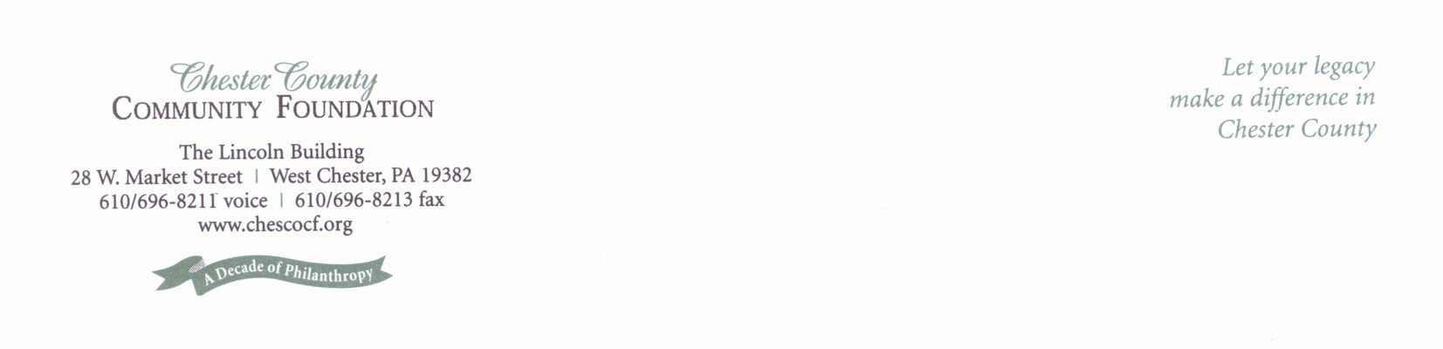
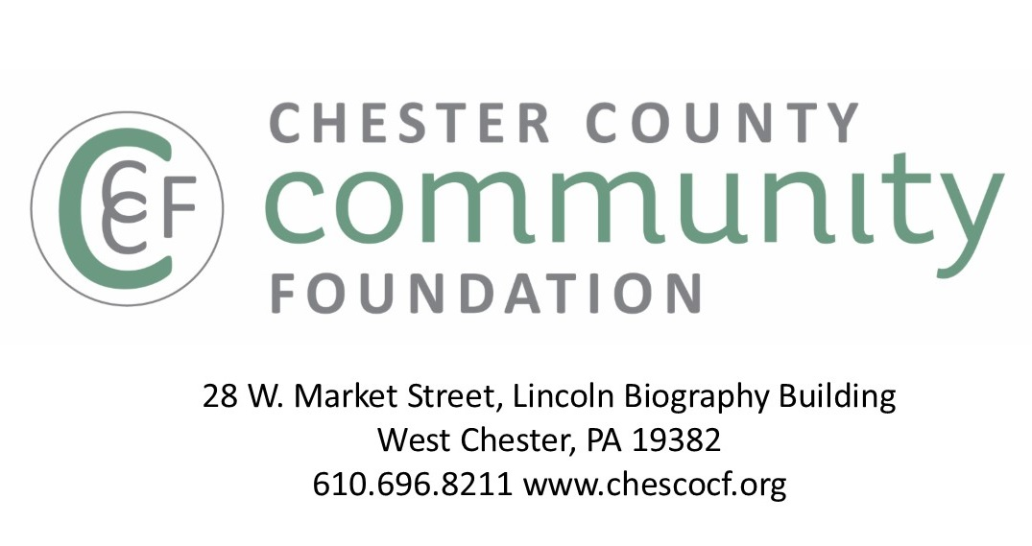
f

GRANT PROPOSAL GUIDELINES

- The Chester County Community Foundation connects people who care with the causes that matter, so their philanthropy makes a difference now & forever.
- We are a collection of Field of Interest & Donor Advised Funds with $5M + granted annually to nonprofits in Chester County & beyond.
- 99% of our grants are made by our generous Fund Advisors, who make grant decisions all year.

Proposals submitted by nonprofits are considered for 2 types of grants:
Fund for Chester County Capacity Building Grants
(Due 9/13)
)
Field of Interest & Donor Advised Funds
(No Deadline)

- Grants focus on Chester County causes & issues, but are not limited to Chester County.
- Charitable nonprofits working in all fields of interest are considered for grant awards. (I.e. arts, culture, & humanities; education; community improvement; environment; religion; health; & human services)
- General operating grants are encouraged. Nonprofits should be specific about their mission, goals, & measurable outcomes.
- Proposals can be submitted anytime all year.
- Grant decisions are made intermittently all year, as Fund Advisors desire.
- Grant awards typically range from $500-$7,500.
- For eligibility in this grant program, nonprofits must be located in & serve Chester County.
- Nonprofits budgets must be $500,000 or less.
- The goal of capacity building grants is to strengthen the effectiveness of NPO’s serving the region, see page 4 for more details on the areas including:
  - Mission, Vision & Strategy
  - Governance & Leadership
  - Partnerships & Collaborations
  - Operations & Technology
  - Fundraising, Development & Marketing
- Proposals submitted between July 1 - Sept. 13 are eligible for consideration.
- Grant awards typically range from $500-$5,000, with monies distributed by February.

- Use this form @ www.chescocf.org to apply online for grants from all Community Foundation Funds.
- Email proposals to grants@chescocf.org
- Proposals are considered “complete” when CCCF has confirmed receipt of the Grant Proposal Summary Sheet, Narrative & Attachments.
- Proposals are shared electronically and online with Fund Advisors, Donors & Grant Panels.
- Per IRS Regulations, applicants must be charitable, tax exempt organizations with 501(c)(3) certification & cannot be individuals.

Please contact Grants Administrator Kevin Baffa at (610)-698-8211 or
grants@chescocf.org with any questions.
- Chester County Community Foundation
Grant Proposal Summary Sheet
One page only. This page will be shared electronically with Grant Panel Members & Fund Advisors.
Note: If Philanthropy Network’s Common Grant Application is used, CCCF’s Summary Sheet MUST accompany application.
To obtain an electronic version of this application, visit www.chescocf.org
Date
Contact Information
Organization Name: ED/CEO Name:
Address: ED/CEO E-mail:
Phone: Board Chair Name:
Website: Board Chair Approval (check here):
Year Incorporated: Primary Contact Name:
FEIN: Primary Contact E-mail:

Organization Information:
Field/s of Interest:
___ Arts, Culture & Humanities ___ Environment/Animal Welfare ___Education
___ Health ___ Human Services ___ Religion

Mission:

Geographic Area Served (If not all of Chester County, specify primary Chester County regions served):

Describe Population Served & Annual Number of People Served:

Annual Budget $_______________________ ________ # of Full-Time Equivalent Paid Staff
________ % of budget for program expenses ________ # of Board Volunteers
________ % of budget for administrative expenses ________ # of Active Non-Board Volunteers
________ % of budget for fundraising expenses ________ # of Volunteer Hours
100 % total

Top 3-5 funding sources:

Is this grant proposal for: Capacity Building ___ or General Operating ____?

If Capacity Building Proposal, the focus is:
___Mission, Vision & Strategy ___Governance & Leadership ___Partnerships & Collaborations
___Fundraising, Development & Marketing ___ Technology Other: __________________________

Grant Amount Requested from the Community Foundation: $_______________

Proposal Summary:

II. CHESTER County Community Foundation
Grant Proposal Narrative
Provide clear, concise information. 3 pages maximum.

1. Nonprofit’s history, goals, key achievements & distinctiveness

2. Funding request
    - Description of key initiatives
    - Specific needs & issues to be addressed
    - Why it is important to fund this now
    - How impact & results will be demonstrated

    - For capacity building grant proposals:
      - How will this capacity building initiative impact your nonprofit?
      - How will this impact be measured?
      - Include a description of the expected activities; timeline & costs to implement the initiative. If external consulting services are required, include the anticipated costs & expertise of the consultants to be hired. Include external consultant proposals if applicable.

III. Attachments
E-mail or mail this support information
1. Copy of 501 (c) (3) federal tax-exempt letter
2. List of Board of Directors, with their affiliations
3. Most recent annual report & financial statement, audited if available
4. Itemized organizational operating budget with actual results for prior fiscal year & current fiscal year to date
5. If capacity building initiative, itemized budget (including external consultant’s proposal, if applicable)
6. Current strategic plan. If your nonprofit does not have a current strategic plan, explain why.

- Use this form @ www.chescof.org to apply online for grants from all Community Foundation Funds.
- Email proposals to grants@chescocf.org
- Proposals are considered “complete” when CCCF has confirmed receipt of the Grant Proposal Summary Sheet, Narrative & Attachments.
- Proposals are shard electronically and online with Fund Advisors, Donors & Grant Panels.
- Per IRS Regulations, applicants must be charitable, tax exempt organizations with 501(c)(3) certification & cannot be individuals.
Please contact Grants Administrator Kevin Baffa at
(610) 696-8211 grants@chescocf.org with questions.

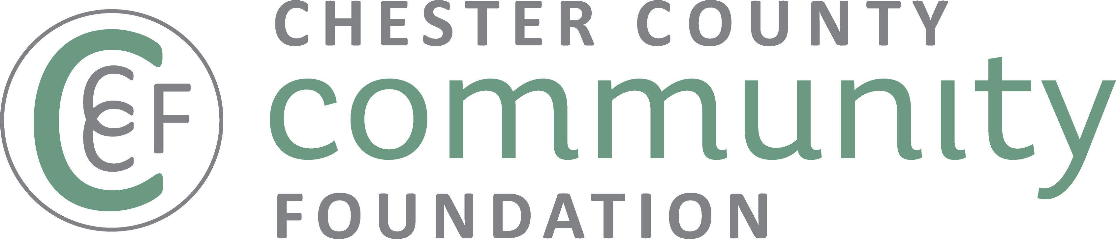
Connecting people who care with causes that matter,
so their legacies make a difference.

WHAT IS CAPACITY BUILDING?
Capacity building helps bring a nonprofit to the next level of operational, programmatic, financial, or organizational maturity, in order to more effectively & efficiently fulfill its mission.
Capacity building may include (but is not limited to) projects which address:

- Mission, Vision & Strategy
Organizational Assessment - Strategic Planning - Financial Planning

- Governance & leadership
Board Development - Executive Transition/Succession Planning - Leadership Development - Staff Training &
Professional Development

- Partnerships & Collaborations
Coalition Building – Collaboration - Mergers & Acquisitions - Strategic Restructuring

- RESOURCE development & Marketing
Major Gift Donor Identification, Cultivation, Development & Stewardship - Development Campaigns (Annual, Capital, Planned Giving) - Earned Income Development - Social Enterprise Feasibility & Development - Marketing, Branding & Communications

- Technology & Operations
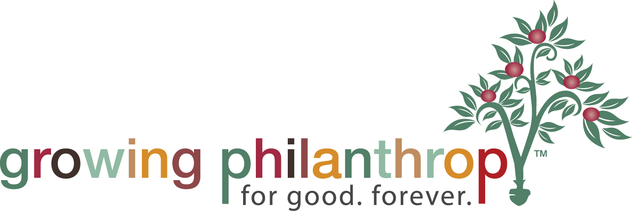
Business Continuity Planning - Financial Management - Human Resources - Volunteer Management - Industry Certification - Risk Management - Technology Improvements

