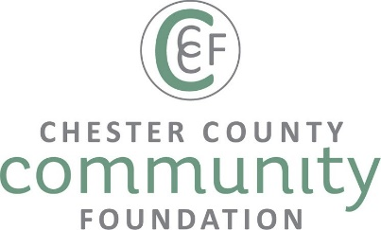

PEER LEARNING CIRCLES

REAL WORLD ANSWERS FOR REAL WORLD PROBLEMS
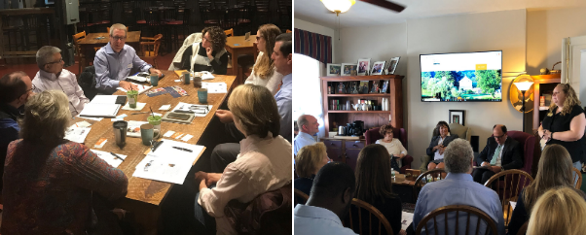
NETWORK WITH COLLEAGUES WHO FACE SIMILAR COMPLEX CHALLENGES AND OPPORTUNITIES
GET SUPPORT AND COACHING FROM PEERS TAKE ACTIONS AND LEARN FROM THEM
EXPERIMENT WITH NEW IDEAS BEFORE “TAKING THEM PUBLIC”
ACHIEVE PERSONAL AND PROFESSIONAL GOALS

Hear what others have to say about CCCF's Peer Learning Circles!
“A nonprofit learning circle is a great way to share ideas, information, and support. It is wonderful to bring an issue to the table and have people who really understand the reality of nonprofit management listen and brainstorm. … The facilitator keeps us on task and focused so we don’t turn it into a gripe session. Absolutely worth my time.”
“I have found learning circle discussions invaluable. They help me interact with Board, staff and donors. Our discussions have definitely given me more confidence in my new role.”
“The process of learning and sharing the issues that face us as nonprofit leaders has helped me keep my own issues in perspective and has helped me develop strategies for our nonprofit to be as effective and proactive as possible.”

Now Accepting Members for 3 Peer Learning Circles in West Chester

3

Nonprofit Executive Directors
1
2
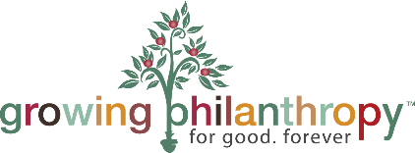
Nonprofit Development Managers
Planned Giving Professionals

Learning Circles are based on action-learning. Adults learn best when they apply new information to real-world, current challenges.

Learning Circles provide peers the opportunity to learn from their own and others’ experiences, and to immediately test and apply their learning at their nonprofits. Learning Circles lead to higher achievement … greater productivity … improved communication …and increased well-being.

Learning Circles are composed of 4-7 peers in the same type of position, in non-competing nonprofits, who commit to self- directed problem solving. Members meet to discuss current nonprofit concerns, share insights and experiences, support and question each other, and jointly problem solve.

In Learning Circle meetings, members work on individual goals and issues related to their nonprofit.
Each member commits to taking action between meetings to address their goals.

Each 1.5 hour session is led by a skilled facilitator with extensive knowledge of the nonprofit sector who manages the process and discussion. Groups are confidential, supportive and focused on learning and action.

A wide range of issues are addressed in Peer Learning Circles:

…balancing personal, professional and community responsibilities
…managing staff / board relationships and responsibilities
…dealing with people whose personal issues affect their nonprofit performance
…identifying competencies to leverage growth

Sessions focus on group members helping each other achieve their nonprofit goals through highly focused questioning and feedback. By the end of each session, peers reflect on the quality of the process to ensure that it remains highly relevant and productive.

SELF
NP ORG
NP SECTOR

Peer Learning Circles are now accepting members for meetings at the Chester County Community Foundation in West Chester!

EXECUTIVE DIRECTORS

GROUP 1 DATES:
10/13/23 | 11/10/23 | 01/12/24 | 02/09/24
03/08/24 | 04/13/24 | 05/10/24 | 06/07/24
GROUP 2 DATES:
10/20/23 | 11/17/23 | 01/19/24 | 02/16/24
03/15/24 | 04/19/24 | 05/17/24 | 06/14/24
TIME: 9:00A – 10:30M
FACILITATOR: Connie Carter, CFRE
*8 sessions @$25/session = $200/year
DEVELOPMENT MANAGERS

GROUP 1 DATES:
10/13/23 | 11/10/23 | 01/12/24 | 02/09/24
03/08/24 | 04/13/24 | 05/10/24 | 06/07/24
GROUP 2 DATES:
10/20/23 | 11/17/23 | 01/19/24 | 02/16/24
03/15/24 | 04/19/24 | 05/17/24 | 06/14/24
TIME: 11:30A – 1:00P
FACILITATOR: Connie Carter, CFRE
*8 sessions @$25/session = $200/year
PLANNED GIVING

TENTATIVE DATES:
11/08/23 | 01/17/24 | 03/13/24 | 05/08/24
TIME: 12:00P – 1:00P
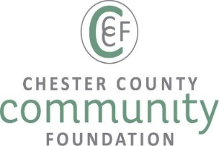
FACILITATOR: Jason Arbacheski, CAP
*4 sessions @$25/session = $100/year

PEER LEARNING CIRCLE
APPLICATION FORM
___ Yes, I would like to apply to join a Nonprofit Peer Learning Circle at the Community Foundation.
___ I have my attached professional resume to this application &/or
___ I have connected with the Chester County Community Foundation, so you can learn about me on
LinkedIn.
___ I agree to sign a confidentiality agreement and hold peer conversations strictly private. I understand that if I divulge confidential information, I will be removed from the Peer Learning Circle.
___ If accepted into the Peer Learning Circle, I agree to pre-pay to cover a year’s worth of meetings.
(The Community Foundation will e-mail invoice once accepted to the Peer Learning Circle)
___ I commit to attending meetings for the coming year.

Name:
Position:
Nonprofit Organization:
Address, City, State, Zip:
Phone:
E-mail:
# of years affiliated with current nonprofit: _____
# of years active in the nonprofit sector: _____
Nonprofit’s Mission:
Geographic Area Served:
Please e-mail application to:
Stephenie Stevens, Grants Director & Outreach Officer
Chester County Community Foundation
28 W. Market Street, West Chester, PA 19382
(610) 696-0501 steph@chescocf.org
Applications are due by Sept. 15th

Peer Learning Circles are a nonprofit capacity building service of the Community Foundation. EIN #23-2773822

