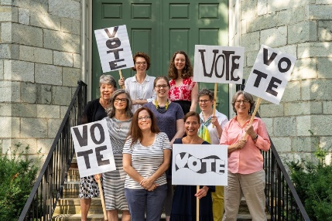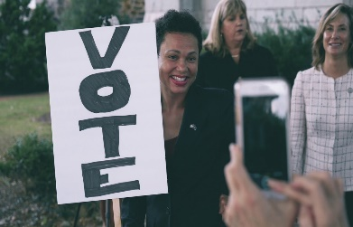

***For good. For all. Forever.***

**VOTER ENGAGEMENT MINI-GRANTS**

**FAST TRACK APPLICATION**

Per IRS Regulations, applicants must be charitable, tax-exempt organizations with 501(c)(3) certification.

**Contact Information**

Organization Name: ED/CEO Name:

Address: ED/CEO E-mail:

Phone: Board Chair Name:

Website: Board Chair Approval (check here):

Year Incorporated: Primary Contact Name:

FEIN: Primary Contact E-mail:

**Organization Information**

**Field/s of Interest:**

|  |  |  |  |
| --- | --- | --- | --- |
| ___Arts, Culture, Heritage, Humanities | ___Environment/Animal Welfare | ___Education | ___Other: |
| ___Health | ___Human Services | ___Religion |

**Mission:**

**Chester County Geographic Area Served** *(If not all of Chester County, specify primary Chester County regions served):*

**Describe Population Served & Annual Number of People Served** *(Note: This funding is especially intended to engage young voters, new voters, BIPOC and historically underrepresented populations.)*

**Annual Budget** $_______________________ ________ # of Full-Time Equivalent Paid Staff

________ % of budget for program expenses ________ # of Board Volunteers

________ % of budget for administrative expenses ________ # of Active Non-Board Volunteers

________ % of budget for fundraising expenses ________ # of Volunteer Hours

*100 % total*

**Voter Engagement Mini-Grant Amount Requested from the Community Foundation**:

___$500 ___$1,000 ___$2,000

**What Voter Engagement Activities Would These Funds Be Used Towards?**

|  |  |  |  |
| --- | --- | --- | --- |
| **Yes/No?** | **Activity** | **When?** | **Where?** |
|  | **Host voter registration events** |  |  |
|  | **Canvass** |  |  |
|  | **Conduct other voter outreach aimed at increasing voter turnout** |  |  |
|  | **Transport voters to the polls** |  |  |
|  | **Other:** |  |  |

Email this Fast-Track Application to Grants Administrator Kevin Baffa at [**grants@chescocf.org**](mailto:grants@chescocf.org)

Grant decisions made weekly. Questions? Call Kevin Baffa at (610) 696-8211.