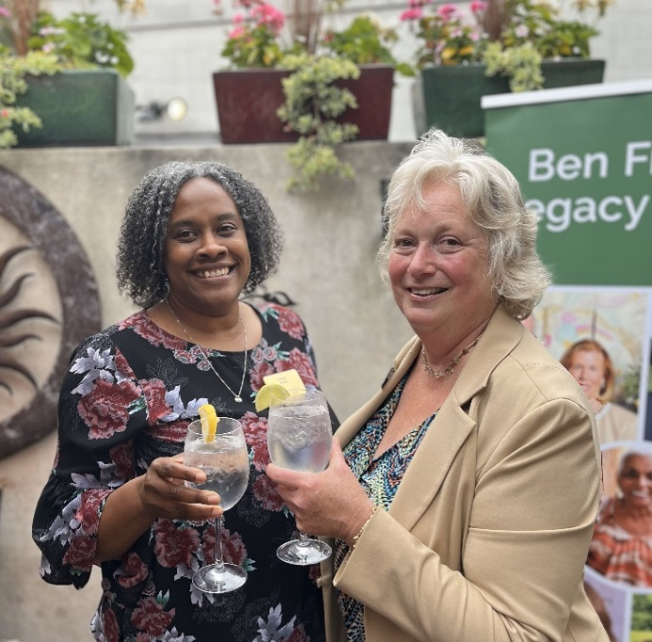
Community Foundation Welcomes Chaya Scott

(West Chester, PA – June 23, 2025): The Chester County Community Foundation welcomes Chaya Scott, BA, MA, CAP® as Chief Program Officer & Philanthropy Planning Officer.

In her new role, Chaya will help focus programs, initiatives, research, and engagement, to enhance the Community Foundation’s role in addressing community needs, growing philanthropy, and strengthening the nonprofit sector.

Chaya will work closely with President/CEO Karen Simmons to ensure that the Community Foundation continues to drive positive change, strengthen the regional philanthropic ecosystem, engage donors, support nonprofits, and sustain long-term impact in Chester County, Now & Forever.

Chaya comes to the Community Foundation with a distinguished career marked by specialized competencies, extensive experience, and a deep-rooted dedication to the nonprofit sector. Most recently, Chaya served as Vice President of Consulting for the Nonprofit Finance Fund. For three years, Chaya led a talented team of 25 consultants who partnered with nearly 200 nonprofit, philanthropy, and government entities. They offered insights, recommendations, and tools to strategically navigate complex financial challenges. With offices in Boston, Los Angeles, New York City, Oakland and Philadelphia, the Nonprofit Finance Fund boosts the collective success and power of nonprofits to advance community wealth and well-being through capital, consulting and advocacy.

Chaya explains, “I’m grateful for my experience with the Nonprofit Finance Fund. It provided a unique window into the strengths, challenges, and resilience of nonprofits, nationally. I look forward to applying what I've learned in the region I call home, and to making a difference where I live. Joining the Community Foundation is the right next step for me.”

Many in the community know Chaya as “the girl next door who keeps on achieving,” per Alice Hammond, immediate Past President of West Chester’s NAACP. “I saw Chaya grow up in West Chester on Miner Street. Then I saw her go to college, work at some terrific nonprofits, start teaching at college, and share her knowledge and experience by consulting with nonprofits. Chaya is an amazing person who keeps on growing and keeps on giving to the community.”

For over two decades, Chaya has juggled many professional responsibilities extremely well, dedicated to shaping dynamic, mission-driven organizations through tailored strategies and impactful leadership development. She’s done this via Chaya Scott Consulting LLC while serving as an Adjunct Professor of Public Policy and Administration at West Chester University for five years and Project Executive for Temple University Fox School of Business, Strategic Management program for four years.

Chaya also worked with the Brandywine Health Foundation (now the Alliance for Health Equity), launching the extremely successful Coatesville Youth Initiative (CYI). At CYI, Chaya sustained more than 40 partnerships and collaborations, supporting 3,000 Coatesville Area School District youth and a newly emerged network of coordinated resources for youth, families, and the community. Per her colleague at the time, Frances Sheehan, now President of The Foundation for Delaware County, “Chaya is exceptional at developing the talent of staff and volunteers and building consensus within diverse coalitions to address local needs. She has a deep commitment to community engagement and the power of philanthropy, making her an ideal fit for the Chester County Community Foundation.”

Prior to CYI, Chaya founded Succeeding Abundantly and served as Executive Director of Phoenixville Area Positive Alternatives. She started her career, fresh out of college, overseeing the Learning for Life program with Chester County Council of Boy Scouts of America.

Chaya sees education as a key to advancement, and she is a continual learner. After graduating from Henderson High School in West Chester, she earned her BA in Public Relations from Temple University and went on to Immaculata University to earn her MA in Organizational Leadership. A few years ago when she wanted to know more about planned giving, she earned her Chartered Advisor in Philanthropy (CAP®) designation from The American College of Financial Services in King of Prussia.

CEO Karen Simmons is delighted to have Chaya on the Community Foundation team: “Chaya has experience in so many types of organizations, and deep and wide expertise in the management and governance of nonprofits and philanthropies. Her heart is in social impact. I have watched over the years as Chaya builds thriving organizational cultures that align mission, values and practices so that staff, board, volunteers and constituents feel listened to, heard, and connected. Chaya builds consensus with diverse community stakeholders, assesses and addresses constituent needs, and implements creative strategies to accomplish systemic change. Just what the world needs!”

Karen continues, “We are thrilled that Chaya has chosen to focus her talents on Chester County again. It is wonderful to see Chaya at local events. It turns out she needs no introduction…people look at her, do a double-take, and say, ‘So incredible to see you again. Glad you are working closer to home. Let’s get together, catch up and see what good things we can do.’”

Chaya Scott is a natural, connecting people who care with causes that matter, so their legacy philanthropy makes a difference now and forever.

Photo: Chaya Scott with Karen Simmons

***

About the Chester County Community Foundation: Headquartered in West Chester’s Lincoln Building, the Chester County Community Foundation connects people who care with causes that matter so their legacy philanthropy makes a difference now and forever. The Community Foundation holds over $130 million in trust and annually awards $6+ million in grants and scholarships. To learn more about the Community Foundation, visit www.chescocf.org. Contact Chaya Scott at chaya@chescocf.org.
###

