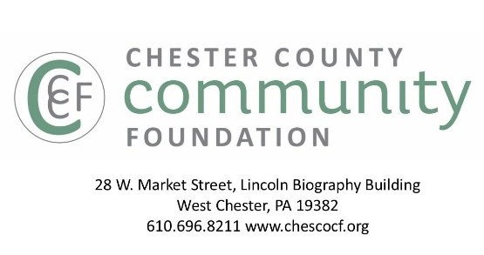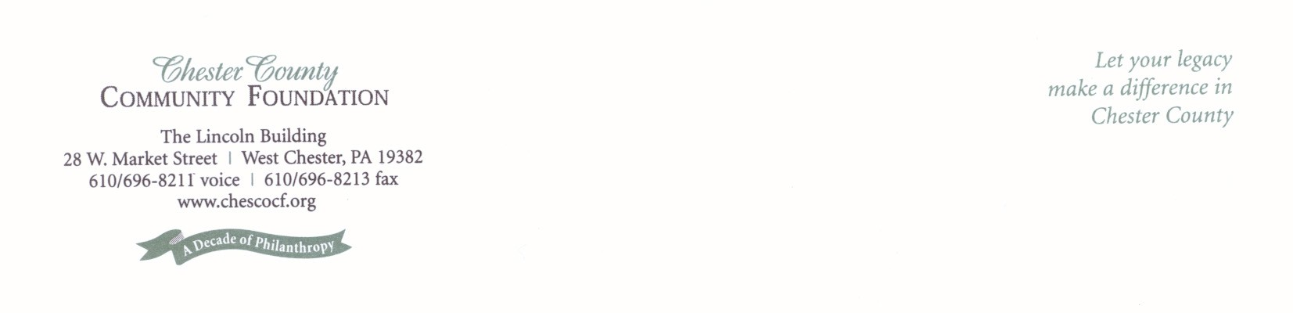f

**GRANT PROPOSAL GUIDELINES**

* The Chester County Community Foundation **connects people who care with the causes that matter**, so their philanthropy makes a difference **now & forever**.
* We are **a collection of Field of Interest** & **Donor Advised Funds** with **$5M + granted annually** to nonprofits in Chester County & beyond.
* **99%** of our grants are made by our generous Fund Advisors, who make grant decisions all year.

Proposals submitted by nonprofits are considered for 2 types of grants:

Fund for Chester County Capacity Building Grants

(Due 9/10)

)

Field of Interest & Donor Advised Funds

(No Deadline)

* For eligibility in this grant program, nonprofits must be **located in & serve only Chester County**.
* Nonprofits **budgets** must be **$500,000 or less.**
* The goal of capacity building grants is to **strengthen the effectiveness of NPO’s serving the region,** see page 4 for more details on theareas including:
  + Mission, Vision & Strategy
  + Governance & Leadership
  + Partnerships & Collaborations
  + Operations & Technology
  + Fundraising, Development & Marketing
* Proposals submitted between **July 1 -** **Sept. 10** are eligible for consideration.
* Grant **awards** typically range from **$1,000-$5,000**, with monies distributed by **February.**
* Grants **focus on Chester County** causes & issues, but are not limited to Chester County.
* Charitable nonprofits working **in all fields of interest** are considered for grant awards. (I.e. arts, culture, & humanities; education; community improvement; environment; religion; health; & human services)
* **General operating** grants are encouraged. Nonprofits should be specific about their mission, goals, & measurable outcomes.
* Proposalscan be submitted **anytime all year**.
* Grant decisions are made **intermittently** all year, as Fund Advisors desire.
* Grant **awards** typically range from **$1,000-$7,500.**

* Use this form @ [www.chescocf.org](http://www.chescocf.org) to apply online for grants from all Community Foundation Funds.
* Email proposals to [grants@chescocf.org](mailto:grants@chescocf.org)
* Proposals are considered “complete” when CCCF has confirmed receipt of the Grant Proposal Summary Sheet, Narrative & Attachments.
* Proposals are shared electronically and online with Fund Advisors, Donors & Grant Panels.
* Per IRS Regulations, applicants must be charitable, tax exempt organizations with 501(c)(3) certification & cannot be individuals.

Please contact Grants Administrator Kevin Baffa at (610) 696-8211 or

[grants@chescocf.org](mailto:grants@chescocf.org) with any questions.

1. **Chester County Community Foundation   
   Grant Proposal Summary Sheet**

***One page only****. This page will be shared electronically with Grant Panel Members & Fund Advisors.*

*Note: If Philanthropy Network’s Common Grant Application is used, CCCF’s* ***Summary Sheet MUST accompany application.***

*To obtain an electronic version of this application, visit* [*www.chescocf.org*](http://www.chescocf.org)

**Date**

**Contact Information**

Organization Name: ED/CEO Name:

Address: ED/CEO E-mail:

Phone: Board Chair Name:

Website: Board Chair Approval (check here):

Year Incorporated: Primary Contact Name:

FEIN: Primary Contact E-mail:

**Organization Information:**

**Field/s of Interest:**

___ Arts, Culture & Humanities ___ Environment/Animal Welfare ___Education

___ Health ___ Human Services ___ Religion

**Mission:**

**Geographic Area Served** *(If not all of Chester County, specify primary Chester County regions served):*

**Describe Population Served & Annual Number of People Served:**

**Annual Budget** $_______________________ ________ # of Full-Time Equivalent Paid Staff

________ % of budget for program expenses ________ # of Board Volunteers

________ % of budget for administrative expenses ________ # of Active Non-Board Volunteers

________ % of budget for fundraising expenses ________ # of Volunteer Hours

*100 % total*

**Top 3-5 funding sources:**

**Is this grant proposal for:** Capacity Building ___ or General Operating ____?

**If Capacity Building Proposal, the focus is:**

___Mission, Vision & Strategy ___Governance & Leadership ___Partnerships & Collaborations

___Fundraising, Development & Marketing ___ Technology Other: __________________________

**Grant Amount Requested from the Community Foundation**: $_______________

**Proposal Summary:**

**II. CHESTER County Community Foundation**

**Grant Proposal Narrative**

Provide clear, concise information. 3 pages maximum.

**1. Nonprofit’s history, goals, key achievements & distinctiveness**

**2. Funding request**

* + - **Description of key initiatives**
    - **Specific needs & issues to be addressed**
    - **Why it is important to fund this now**
    - **How impact & results will be demonstrated**
    - *For capacity building grant proposals:*
      * *How will this capacity building initiative impact your nonprofit?*
      * *How will this impact be measured?*
      * *Include a description of the expected activities; timeline & costs to implement the initiative. If external consulting services are required, include the anticipated costs & expertise of the consultants to be hired. Include external consultant proposals if applicable.*

**III. Attachments**

***E-mail or mail this support information***

1. Copy of 501 (c) (3) federal tax-exempt letter

2. List of Board of Directors, with their affiliations

3. Most recent annual report & financial statement, audited if available

4. Itemized organizational operating budget with actual results for prior fiscal year & current fiscal year to date

5. If capacity building initiative, itemized budget (including external consultant’s proposal, if applicable)

6. Current strategic plan. If your nonprofit does not have a current strategic plan, explain why.

* Use this form @ [www.chescof.org](http://www.chescof.org) to apply online for grants from all Community Foundation Funds.
* Email proposals to [grants@chescocf.org](mailto:grants@chescocf.org)
* Proposals are considered “complete” when CCCF has confirmed receipt of the Grant Proposal Summary Sheet, Narrative & Attachments.
* Proposals are shard electronically and online with Fund Advisors, Donors & Grant Panels.
* Per IRS Regulations, applicants must be charitable, tax exempt organizations with 501(c)(3) certification & cannot be individuals.

Please contact Grants Administrator Kevin Baffa at   
(610) 696-8211 [**grants@chescocf.org**](mailto:grants@chescocf.org) with questions.



***Connecting people who care with causes that matter,  
 so their legacies make a difference.***

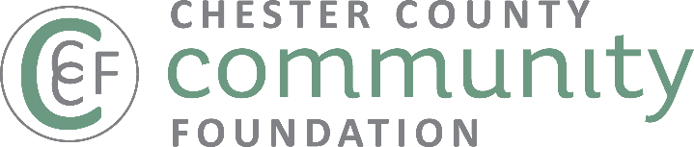

**WHAT IS CAPACITY BUILDING?**

**Capacity building helps bring a nonprofit to the next level of operational, programmatic, financial, or organizational maturity, in order to more effectively & efficiently fulfill its mission*.***

Capacity building may include (but is not limited to) projects which address:

* **Mission, Vision & Strategy**

Organizational Assessment - Strategic Planning - Financial Planning

* **Governance & leadership**

Board Development - Executive Transition/Succession Planning - Leadership Development - Staff Training &

Professional Development

* **Partnerships & Collaborations**

Coalition Building – Collaboration - Mergers & Acquisitions - Strategic Restructuring

* **RESOURCE development & Marketing**

Major Gift Donor Identification, Cultivation, Development & Stewardship - Development Campaigns (Annual, Capital, Planned Giving) - Earned Income Development - Social Enterprise Feasibility & Development - Marketing, Branding & Communications

* **Technology & Operations**

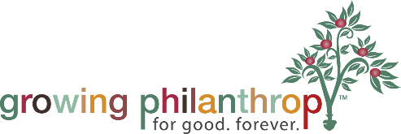Business Continuity Planning - Financial Management - Human Resources - Volunteer Management - Industry Certification - Risk Management - Technology Improvements