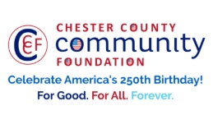
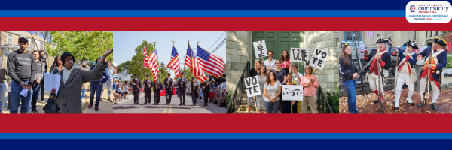

LET FREEDOM RING
AMERICA250 GrANT APPLICATION FORM
Chester County Community Foundation
An electronic version of this application is available at https://cccf250.org/planning/
Contact Information
Contact Person Name: Lara Kennedy
Organization Name: Founding Forward
Address: 1601 Valley Forge Rd
Phone: 301-520-2336
Email: KennedyL@foundingforward.org
Website: www.foundingforward.org
Year Incorporated: 1947
FEIN #: 26-1894379
Note: Please attach a copy of your 501c3 letter with this request. Per IRS regulations, grants can be awarded to nonprofit charities and municipalities, but NOT individuals nor businesses.

Organization Field of Interest
X | Arts, Culture, Heritage |  | Environment, Animals |  | X | Education, Library
 | Health & Human Services |  | Social Justice, Civil Rights |  |  | Religion
 | Municipality/Governmental |  | If other, please describe:

A lot | Some | A little
X |  |  | This inspires & engages a wide array of people in commemoration of America’s founding with our Revolutionary Declaration of Independence.
X |  |  | This connects Chester County’s stories to the nation’s past, present & future.
X |  |  | This commemoration is truly by the people, for all people. We invite wide input & welcome all to actively participate.
 | X |  | This examines & fosters fundamental rights of Life, Liberty & the Pursuit of Happiness for All.
 | X |  | We zoom in to CCCF250 planning meetings to share information & ideas.

Amount Requested from the Community Foundation:
 | $250 |  | $1,250 |  | $2,250 |  | $5,250 | X | $10,250

Please BRIEFLY describe how this funding will help your programs, services, activities and/or events to celebrate and commemorate the 250th anniversary of our nation’s Declaration of Independence, and our continuing journey toward liberty and justice for all.
What are you doing? When? Who will it impact? What difference do you aim to make?
What will it cost overall? Who are you partnering & coordinating with?

Please e-mail this Mini-Grant request with your 501c3 letter to grants@chescocf.org
Let Freedom Ring Mini-Grant decisions are made on the 25th of each month.
Questions? Contact Grants Officer Stephenie Stevens (610) 696-8211 grants@chescocf.org
For Good. For All. Forever.

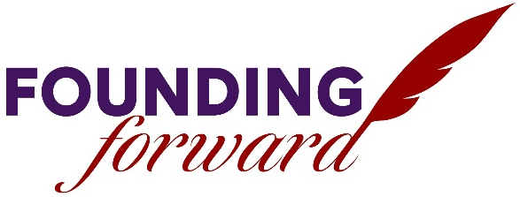

Founding Forward Trail Project- Connecting the Medal of Honor Grove to
Geroge Washington’s Headquarters in Valley Forge National Park

Founding Forward’s mission is to inform and engage citizens through transformational educational experiences grounded in American history. To that end, Founding Forward provides educational programs on the 75-acre Valley Forge campus adjacent to Valley Forge National Historical Park for students, teachers, and the community.

The Medal of Honor Grove, part of the Founding Forward campus, is a 42-acre conserved level 1 arboretum, designed as a living memorial to over 3,500 recipients of the nation's highest military decoration. Each Medal of Honor recipient is identified by a marker with name, branch, and the date and location of the act of valor. The Grove is open from sunrise to sunset, and provides an experiential learning opportunity in a quiet, peaceful environment.

Valley Forge National Historical Park is nationally significant as the site of the 1777-78 winter encampment of the Continental Army under General George Washington. Few places evoke the spirit of patriotism and independence, represent individual and collective sacrifice, or demonstrate the resolve, tenacity and determination of the people of the United States to be free as well as Valley Forge. The historic landscapes, structures, objects, and archeological and natural resources at Valley Forge are tangible links to one of the most defining events in our nation's history.

The goal is to build a trail connecting Founding Forward's Medal of Honor with George Washington's Headquarters in Valley Forge National Park. The trail will create a direct link between two publicly accessible educational spaces exploring the historical significance of the American founding. It will do more than provide a practical connector for the community to access both sites, it will stand as an important symbolic union between the birthplace of the modern United States Army, and the site where the valiant efforts made by those armed forces are commemorated. As the nation looks toward the 250th anniversaries of the founding and the encampment at Valley Forge, this partnership and the resulting trail will create a substantial lasting impact and help visitors to consider the sacrifices made to protect the rights and responsibilities of American citizenship enshrined in the Declaration of Independence and Constitution of the United States.

The expected outcome will create a publicly accessible trail. The best way to accomplish this will be to build the trail along the border of right-of-way between Founding Forward property, National Park property, and Norfolk Southern railroad property, as this will utilize previously disturbed land and will therefore avoid the need for additional extensive archeological and environmental study and consultation. Norfolk Southern has approved the lease of the right-of-way land for this intended use, and Valley Forge Park officials have added their support for the project using this alignment. For the purposes of construction, the project will be divided into three sections of trail; a flat portion leading from Valley Forge train station to the Medal of Honor Grove, a ramp traversing approximately 66 feet of elevation, and a section from the Medal of Honor grove to the Founding Forward parking lot, creating a defined trailhead.

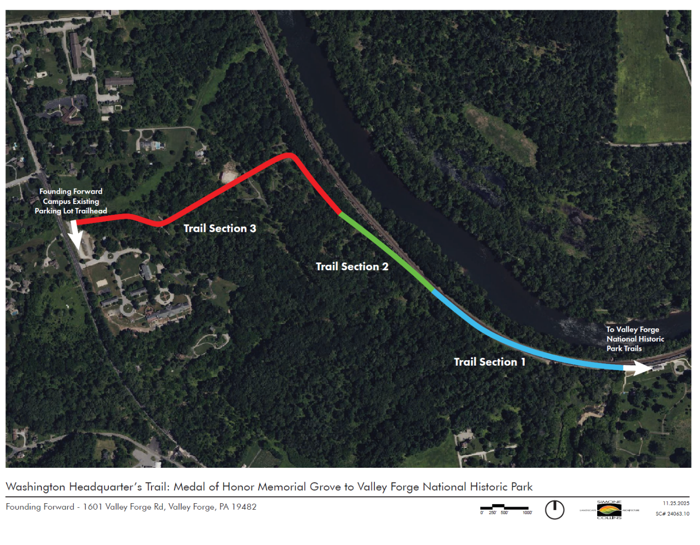
A map of the proposed project is included below:
Section two of the above concept plan traverses approximately 66 feet in elevation over an approximate horizontal distance of 910 feet. The trail would be designed at a maximum slope of 8% for a maximum distance of 200 feet. Every 200 feet there would be a level landing area measuring 10 feet by 10 feet. The 8% slope is ADA compliant based on federal highway administration standards for trails. The trail would be designed to be 10 feet wide.

A drafted timeline of activities is included below:
- September 2025: Meeting/walk alignment w/ landscape architecture firm for feasibility study.
- September 2025: Meeting with township officials
- November 2025: Progress meeting
- December 2025: Meeting with DCNR representatives
- December 2025/January 2026: Progress meeting
- January 2026: Meeting with Valley Forge Park superintendent/staff
- January 2026: Formation of steering committee for project
- February 2026: Progress meeting
- March 2026: Plan presentation
- March 2026: Public meeting
- April 2026: DCNR funding application
- Spring/Summer 2026: Construction RFP
- Summer 2026: Public meeting
- Summer/Fall 2026: Construction begins

A preliminary cost estimate is included below, provided via third-party landscape architecture firm performing feasibility study.

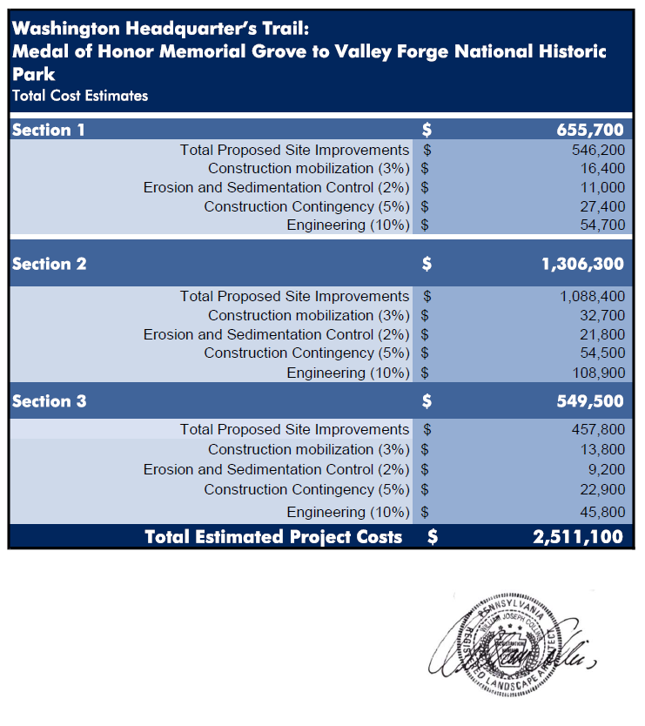
Founding Forward is requesting a grant award of $10,250 from the Chester County Community Foundation in support of this project. These funds will assist with matching requirements for state funding and will help to ensure that the project stands as a lasting physical commemoration of Chester County’s pivotal role in the founding of the nation.
Point of contact: Lara Kennedy, Advancement Manager
KennedyL@foundingforward.org
301-520-2336

