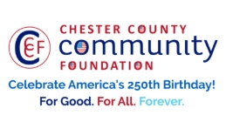
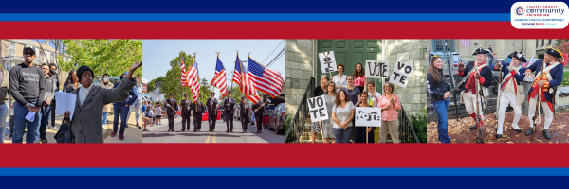

LET FREEDOM RING
AMERICA250 GrANT APPLICATION FORM
Chester County Community Foundation
An electronic version of this application is available at https://cccf250.org/planning/
Contact Information
Contact Person Name: Sarah Lacour
Organization Name: Avon Grove Library
Address: 117 Rosehill Avenue West Grove, PA 19390
Phone: 610-869-2004
Email: slacour@ccls.org
Website: www.avongrovelibrary.org
Year Incorporated: 1966
FEIN #: 23-1371963
Note: Please attach a copy of your 501c3 letter with this request. Per IRS regulations, grants can be awarded to nonprofit charities and municipalities, but NOT individuals nor businesses.

Organization Field of Interest
x | Arts, Culture, Heritage |  | Environment, Animals |  | x | Education, Library
 | Health & Human Services |  | Social Justice, Civil Rights |  |  | Religion
 | Municipality/Governmental |  | If other, please describe:

A lot | Some | A little
x |  |  | This inspires & engages a wide array of people in commemoration of America’s founding with our Revolutionary Declaration of Independence.
x |  |  | This connects Chester County’s stories to the nation’s past, present & future.
x |  |  | This commemoration is truly by the people, for all people. We invite wide input & welcome all to actively participate.
x |  |  | This examines & fosters fundamental rights of Life, Liberty & the Pursuit of Happiness for All.
 | x |  | We zoom in to CCCF250 planning meetings to share information & ideas.

Amount Requested from the Community Foundation:
 | $250 | x | $1,250 |  | $2,250 |  | $5,250 |  | $10,250

Please BRIEFLY describe how this funding will help your programs, services, activities and/or events to celebrate and commemorate the 250th anniversary of our nation’s Declaration of Independence, and our continuing journey toward liberty and justice for all.
What are you doing? When? Who will it impact? What difference do you aim to make?
What will it cost overall? Who are you partnering & coordinating with?

Please e-mail this Mini-Grant request with your 501c3 letter to grants@chescocf.org
Let Freedom Ring Mini-Grant decisions are made on the 25th of each month.
Questions? Contact Grants Officer Stephenie Stevens (610) 696-8211 grants@chescocf.org
For Good. For All. Forever.
Avon Grove Library is seeking a grant to facilitate a series of art workshops and a gallery show to celebrate the nation’s 250th anniversary and highlight Chester County history from June through August of 2026. The library will host a series of free art workshops that use local author Mark Lanyon’s Lost Chester County Pennsylvania as source material to make art inspired by the County’s history. Workshops will draw from sections: “Chapter 1: Native Americans in Chester County”, “Chapter 3: Villages/Buildings”, “Chapter 4: Schools”, “Chapter 5: Manufacturing”, “Chapter 6: Entertainment and Recreation”, “Chapter 7: Underground Railroad”, “Chapter 8: Women’s Suffrage”, and Chapter 9: Wartime in Chester County”.Each workshop will highlight different mediums, styles and artists appropriate to the time period of focus, including but not limited to: painting, drawing, printmaking, and sculpture. Combined with historic photographs, paintings, and illustrations these sections will be used to inspire art making. Workshop attendees will be encouraged to illustrate scenes and historic figures from the book, highlight lesser known local history, emulate various art movements, and use art as a tool to express reactions, thoughts, and feelings about Chester County’s past, present and future. All ages will be welcome, and workshops will be held at varying levels to encourage participation from youth, family, and teen, and adult audiences.
This series intends to bring together budding artists and historians, community members, local historians and authors, and other community organizations to bring these programs and local Chester County history to life. We plan to bring this program offsite to our community partners at the Chester County Intermediate Unit’s (CCIU) 21st Century Community Learning Center and the Migrant Education Program as well. The goal is to inspire young and old learners to be more engaged in Chester County history with America 250 as the focal point. The program intends to uplift creative expression, not only through learning different methods and mediums of art making in an encouraging environment, but also through hosting a gallery show for the artists that celebrates their work. By working with local historians, artists, and community partners to deliver this free programming during the summer we intend to highlight the value of community collaboration and hope to reach as many community members as possible.
The library is requesting $1,250. We intend to use this grant funding to compensate any community partners that help us facilitate programming, to cover the costs of art supplies, and to host a gallery show with food, beverages, and decorations.

The programs will focus on excerpts that pertain to Southeastern Chester County history. This includes sections: “Chester County: Leni Lenape Tribe”, “Landenberg: Minguannan Indian Town”, “Upper Oxford: Hinsonville”, “Kennett Square Borough: Historic East Linden Street”, “West Grove Borough: West Grove Hospital”, “New London Township: New London Academy”, “West Grove: Casket Factory”, Oxford: Oxford Caramel Factory”, “West Grove: Roselyn Theater”, “Jennersville: Sunset Park”, “Oxford: Wheeler’s Circus”, “Upper Oxford: Hosanna Church”, “West Grove: Ann Preston”, “Upper Oxford: Hinsonville Men & the Union Army”, “Kennett Square: Camp Bloomfield”.

