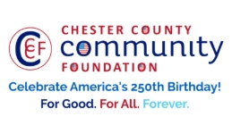
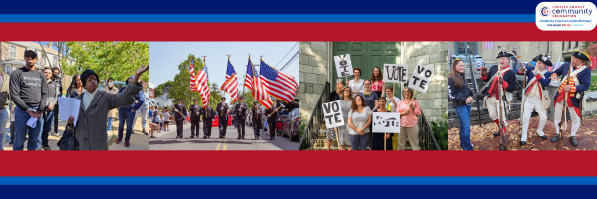

LET FREEDOM RING
AMERICA250 GrANT APPLICATION FORM
Chester County Community Foundation
An electronic version of this application is available at https://cccf250.org/planning/
Contact Information
Contact Person Name: Karen Gorgonzola
Organization Name: Honey Brook Community Library
Address: 687 Comapass Rd. Honey Brook, PA 19344
Phone: 610-273-3303
Email: jspade@ccls.org
Website: honeybrooklibrary.org
Year Incorporated: 1927
FEIN #: 22-2489528
Note: Please attach a copy of your 501c3 letter with this request. Per IRS regulations, grants can be awarded to nonprofit charities and municipalities, but NOT individuals nor businesses.

Organization Field of Interest
 | Arts, Culture, Heritage |  | Environment, Animals |  | X | Education, Library
 | Health & Human Services |  | Social Justice, Civil Rights |  |  | Religion
 | Municipality/Governmental |  | If other, please describe:

A lot | Some | A little
X |  |  | This inspires & engages a wide array of people in commemoration of America’s founding with our Revolutionary Declaration of Independence.
X |  |  | This connects Chester County’s stories to the nation’s past, present & future.
X |  |  | This commemoration is truly by the people, for all people. We invite wide input & welcome all to actively participate.
X |  |  | This examines & fosters fundamental rights of Life, Liberty & the Pursuit of Happiness for All.
 | X |  | We zoom in to CCCF250 planning meetings to share information & ideas.

Amount Requested from the Community Foundation:
 | $250 | X | $1,250 |  | $2,250 |  | $5,250 |  | $10,250

Please BRIEFLY describe how this funding will help your programs, services, activities and/or events to celebrate and commemorate the 250th anniversary of our nation’s Declaration of Independence, and our continuing journey toward liberty and justice for all.
What are you doing? When? Who will it impact? What difference do you aim to make?
What will it cost overall? Who are you partnering & coordinating with?

Please e-mail this Mini-Grant request with your 501c3 letter to grants@chescocf.org
Let Freedom Ring Mini-Grant decisions are made on the 25th of each month.
Questions? Contact Grants Officer Stephenie Stevens (610) 696-8211 grants@chescocf.org
For Good. For All. Forever.
America 250 mini-grant
Let Freedom Ring
Honey Brook Community Library

The Honey Brook Community Library is excited to plan numerous activities to celebrate America’s 250th anniversary. After the completion of a major renovation/expansion project last year, the library now has a spacious community room for a variety of programs and looks forward to utilizing this space in the celebration of the country’s anniversary.
The staff of HBCL has been organizing a speaker series to take place during the course of the next several months which includes the topics of the captivity of Benjamin Gilbert and family in the early 1780’s, the history of the Underground Railroad in Chester County, and a discussion on the diverse backgrounds of the people throughout the years who have called Chester County home.
We anticipate that this variety of presentations will appeal to a wide range of the community especially for those interested in our Quaker roots, the Underground Railroad and its impact in our area, and a better understanding of how present day Chester County came to be. Plans are underway to partner with local historians who enthusiastically share their passion and knowledge of their topics as well as the Chester County History Center which provides speakers on a variety of themes related to past and current issues of Chester County.
Our other set of activities are centered around craft projects with a patriotic theme for adults and children. Approximately 15-20 adults or children participate in the craft programs currently offered, but we predict an increase in number for these special craft events. Possible projects include patriotic wreathes, wall hangings, and other celebratory crafts.
America 250 presents an exciting opportunity for HBCL and its community. With the programming that is planned, we have the chance to reflect on how our country has grown and changed through the years, celebrate where we are at the present time, and encourage active, compassionate citizens for the future.
Costs for these programs are broken down as follows:
Speaker series: $250
Red, white, and blue themed craft supplies for 3 events: $500
Refreshments for craft programs and speaker series: $250
Extra staffing for approximately 6 events: $250
Total cost and grant request: $1250

