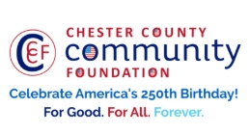
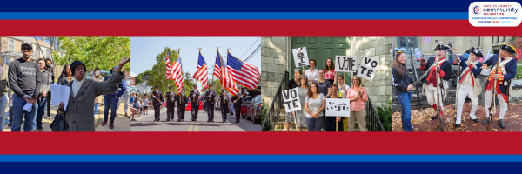

LET FREEDOM RING
AMERICA250 GrANT APPLICATION FORM
Chester County Community Foundation
An electronic version of this application is available at https://cccf250.org/planning/
Contact Information
Contact Person Name: Erica L. Batdorf, Township Manager
Organization Name: North Coventry Township
Address: 845 S. Hanover Street, Pottstown, PA, 19465
Phone: 610-323-1694
Email: ebatdorf@northcoventry.us
Website: northcoventrytownship.com
Year Incorporated: 1841
FEIN #: 236000449
Note: Please attach a copy of your 501c3 letter with this request. Per IRS regulations, grants can be awarded to nonprofit charities and municipalities, but NOT individuals nor businesses.

Organization Field of Interest
X | Arts, Culture, Heritage |  | Environment, Animals |  |  | Education, Library
 | Health & Human Services |  | Social Justice, Civil Rights |  |  | Religion
X | Municipality/Governmental |  | If other, please describe:

A lot | Some | A little
X |  |  | This inspires & engages a wide array of people in commemoration of America’s founding with our Revolutionary Declaration of Independence.
X |  |  | This connects Chester County’s stories to the nation’s past, present & future.
X |  |  | This commemoration is truly by the people, for all people. We invite wide input & welcome all to actively participate.
X |  |  | This examines & fosters fundamental rights of Life, Liberty & the Pursuit of Happiness for All.
X |  |  | We zoom in to CCCF250 planning meetings to share information & ideas.

Amount Requested from the Community Foundation:
 | $250 |  | $1,250 | X | $2,250 |  | $5,250 |  | $10,250

Please BRIEFLY describe how this funding will help your programs, services, activities and/or events to celebrate and commemorate the 250th anniversary of our nation’s Declaration of Independence, and our continuing journey toward liberty and justice for all. Please see Page 2 of this application.
What are you doing? When? Who will it impact? What difference do you aim to make?
What will it cost overall? Who are you partnering & coordinating with?

Please e-mail this Mini-Grant request with your 501c3 letter to grants@chescocf.org
Let Freedom Ring Mini-Grant decisions are made on the 25th of each month.
Questions? Contact Grants Officer Stephenie Stevens (610) 696-8211 grants@chescocf.org
For Good. For All. Forever.
North Coventry Township
Iron Legacy Tour – Grant Proposal Request

Project Summary
The North Coventry Township Historical Commission respectfully requests $2,500.00 in grant support for the Iron Legacy Tour, a guided, history-focused motorcoach tour designed to educate residents and visitors about the region’s rich iron-making heritage and its role in the early development of northern Chester County and the United States. Scheduled for May 9 and May 13, 2026, this program coincides with the 250th anniversary of the United States, offering a timely opportunity to connect local history to the broader national story.
The Iron Legacy Tour will provide an engaging, accessible, and educational experience led by local historians, highlighting significant historic sites that illustrate the industrial, cultural, and social legacy of iron production in the region.

Statement of Need & Budget
Northern Chester County played an important role in Pennsylvania’s early iron industry, yet many of its historic resources and stories remain underrepresented or unknown to the public. As historic sites age and firsthand knowledge diminishes, there is a growing need to preserve, interpret, and share this heritage in meaningful and engaging ways.
The Iron Legacy Tour addresses this need by:
- Increasing public awareness of local historic iron sites
- Encouraging heritage tourism and community pride
- Providing accessible, guided educational programming for diverse audiences
- Supporting preservation efforts through interpretation and engagement
- Honoring the legacy that fostered the Right to Life, Liberty, and the Pursuit of Happiness
Grant funding will help ensure that this program remains affordable, accessible, and professionally presented while reaching a broad audience. The Township’s total project budget is $3,250.00 including our charter rental fee, educational materials, and supplies.
By offering an affordable ticket price and ADA-accessible transportation, the program ensures inclusivity while strengthening community engagement with local history. The tour also supports broader economic and cultural goals by promoting heritage tourism and encouraging stewardship of historic resources.

Thank you for your consideration of our request!

