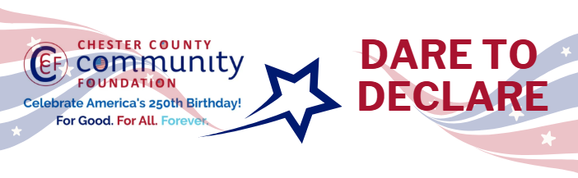

Chester County Community Foundation
“DARE TO DECLARE” MINI-GrANT APPLICATION FORM
An electronic version of this application is available at https://cccf250.org/daretodeclare/
Please note: Per IRS regulations, grants can be awarded to nonprofit charities and municipalities, but NOT individuals nor businesses.
Contact Information
Contact Person Name: Tim Compton, Executive Director
Organization Name: Historic Yellow Springs, Inc.
Address: 1685 Art School Road, Chester Springs, PA 19425
Phone: 610-827-7414 ext. 14
Email: Tcompton@yellowsprings.org
Website: www.yellowsprings.org
Year Incorporated: 1974
FEIN #: 23-1920704
Note: Please attach a copy of your 501c3 letter with this request.

Organization Field of Interest
X | Arts, Culture, Heritage |  | Environment, Animals |  |  | Education, Library
 | Health & Human Services |  | Social Justice, Civil Rights |  |  | Religion
 | Municipality/Govt |  | If other, please describe:

Mini-Grant Amount Requested from the Community Foundation
 | $250 |  | $500 |  | $1,000 |  | $2,000 | X | $2,500

Your Dare to Declare Event:
Date  6/7/2026 | Time  3:00-6:00 | Location Name  Historic Yellow Springs | Location Address  1685 Art School Road, Chester Springs, PA 19425
Please BRIEFLY describe: 1-how this funding will help your Dare to Declare Event, 2-who it will impact, 3-the approximate amount you’ll be spending on Dare to Declare activities overall, and 4-who you are partnering/coordinating with.

1. How this funding will help your Dare to Declare event
Funding will support the successful integration of the Dare to Declare reading of the Declaration of Independence into Historic Yellow Springs’ Jazz at the Springs concert series. And the Radical Americana Exhibition happening at the site simultaneously. Specifically, it will help cover costs for:
- Event production needs (sound reinforcement, staging to ensure the reading is audible and accessible to all attendees).
- Printing of handouts and interpretive materials that explain the historical context of the Declaration of Independence and it’s relevance to the Yellow Springs site and Revolutionary War Hospital.
- Marketing and promotion of the event to increase the number of those able to experience the free event.
This funding ensures that the reading is not just an add-on, but a thoughtfully engaged experience that enhances the cultural and educational impact of the overall event.
2. Who it will impact
The Dare to Declare reading will meaningfully impact:
- Local families and community members of Northern Chester County- using previous year’s attendance, estimated 800–1,000 attendees come from the greater Northern Chester County area. Jazz at the springs is nearly a 30 year tradition to usher in the summer season at Yellow Springs. It is a beloved event in the region.
- Veterans- With the work that Historic Yellow Springs has made in recent years developing veteran focused programming, we have also developed deep connections with veteran groups in the area. Veterans have become a key focus group as we promote programs and events throughout the year.
This activity supports community civic literacy, deepens appreciation for national heritage, and strengthens community bonds through shared public experiences.
3. Approximate amount you’ll be spending on Dare to Declare activities overall
We estimate the total cost for Dare to Declare specific activities to be estimated at $5500
- Audio/PA rental and technician support- $2,000
- Printed materials and signage- $1000
- Marketing and Promotion- $1000
- Equipment tent rental- $1500
4. Who you are partnering/coordinating with
Historic Yellow Springs is partnering and coordinating with:
- CCCF250 / Dare to Declare initiative- for guidance on thematic content, framing of the reading, and promotion
- Jazz at the Springs organizers- to align scheduling, production logistics, and audience engagement strategies.
- Exton Region Chamber Veterans Group- promotion to veterans
- Downingtown VFW Post # 845 - promotion to veterans
- Montgomery School- Promotion to local families
- West Pikeland Township- Promotion and communication of importance.
- Volunteer community readers and performers- drawn from schools, civic groups, and local arts networks
Together, these partners ensure the Dare to Declare reading is firmly rooted in both historical purpose and community celebration.

Please e-mail this Mini-Grant request with your 501c3 letter to grants@chescocf.org
Dare to Declare Mini-Grant decisions are made on the 25th of each month.
Questions? Contact Grants Officer Stephenie Stevens (610) 696-8211 grants@chescocf.org
For Good. For All. Forever.

