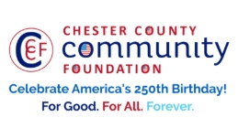
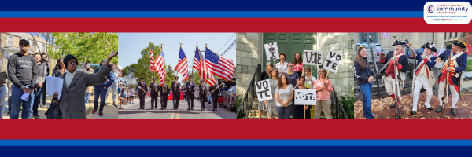

LET FREEDOM RING
AMERICA250 GrANT APPLICATION FORM
Chester County Community Foundation
An electronic version of this application is available at https://cccf250.org/planning/
Contact Information
Contact Person Name: Tim Compton, Executive Director
Organization Name: Historic Yellow Springs, Inc.
Address: 1685 Art School Road, Chester Springs, PA 19425
Phone: 610-827-7414 ext. 14
Email: Tcompton@yellowsprings.org
Website: www.yellowsprings.org
Year Incorporated: 1974
FEIN #: 23-1920704
Note: Please attach a copy of your 501c3 letter with this request. Per IRS regulations, grants can be awarded to nonprofit charities and municipalities, but NOT individuals nor businesses.

Organization Field of Interest
X | Arts, Culture, Heritage |  | Environnent, Animals |  |  | Education, Library
 | Health & Human Services |  | Social Justice, Civil Rights |  |  | Religion
 | Municipality/Governmental |  | If other, please describe:

A lot | Some | A little
X |  |  | This inspires & engages a wide array of people in commemoration of America’s founding with our Revolutionary Declaration of Independence.
X |  |  | This connects Chester County’s stories to the nation’s past, present & future.
X |  |  | This commemoration is truly by the people, for all people. We invite wide input & welcome all to actively participate.
X |  |  | This examines & fosters fundamental rights of Life, Liberty & the Pursuit of Happiness for All.
 | X |  | We zoom in to CCCF250 planning meetings to share information & ideas.

Amount Requested from the Community Foundation:
 | $250 |  | $1,250 |  | $2,250 |  | $5,250 | X | $10,250

Please BRIEFLY describe how this funding will help your programs, services, activities and/or events to celebrate and commemorate the 250th anniversary of our nation’s Declaration of Independence, and our continuing journey toward liberty and justice for all.
What are you doing? When? Who will it impact? What difference do you aim to make?
What will it cost overall? Who are you partnering & coordinating with?

Funding will support PA 250: Reenvisioning the Revolution, a year’s long arts and history initiative at Historic Yellow Springs (Chester Springs, PA) celebrating the 250th anniversary of the Declaration of Independence through the lens of the nation’s first purpose-built Revolutionary War hospital.
Beginning in early 2026 and continuing through 2027, the project will include multiple exhibitions, monthly lectures and hands-on making workshops, free historic tours, and large-scale community festivals that integrate readings of the Declaration of Independence and Revolutionary storytelling. History Exhibitions will include Revolutionizing Medicine (focused on the untold stories of the doctors, nurses, and caregivers at the Yellow Springs Hospital serving Valley Forge), and Planting Seeds of Revolution (focused on the plants and recipes used for healing, and the adaptations happening during the war due to embargos and additions of native knowledge). A contemporary art installation, Radical Americana (in partnership with the Clay Studio in Philadelphia) will focus on the nearby Vickers pottery, a stop on the underground railroad, and how their beliefs manifest in modern clay makers today. A monthly speaker series will dive deeper into these topics and more allowing enthusiasts to engage with the history of this important site.

The initiative is expected to reach more than 22,500 participants, including families, students, veterans, adult learners, and heritage tourists from across the greater Philadelphia region. By highlighting under-told stories of healing, innovation, and care, alongside ideals of liberty and justice, the project aims to deepen public understanding of the Revolution, connect historic medical innovation to modern concepts of public health and civic responsibility, and ensure inclusive, accessible engagement for people of all ages and abilities.

The total anticipated project cost of $20,000 supports exhibitions, artist and historian honoraria, materials, evaluation, and accessibility measures. Historic Yellow Springs serves as lead coordinator and is partnering with organizations including The Clay Studio of Philadelphia, SALT Performing Arts, West Pikeland Township, the Philadelphia Unit of the Herb Society, Chester County History Center, the Mill at Anselma, GoggleWorks Center for the Arts, Pottsgrove Manor, and regional veterans’ organizations, each contributing complementary expertise in scholarship, creative practice, and community engagement.

Please e-mail this Mini-Grant request with your 501c3 letter to grants@chescocf.org
Let Freedom Ring Mini-Grant decisions are made on the 25th of each month.
Questions? Contact Grants Officer Stephenie Stevens (610) 696-8211 grants@chescocf.org
For Good. For All. Forever.

