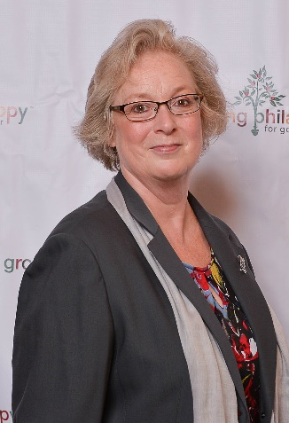
BIOGRAPHY

Karen A. Simmons, President/CEO
Chester County Community Foundation

Karen A. Simmons' first day on the job as President/CEO of the Chester County Community Foundation was 9/11/2001. Starting from that fateful day, Simmons has overseen endowed fund growth from $8 million to $100+ million, with $75 million in the planned gift pipeline. 400+ individual, family and nonprofit charitable endowed funds are housed under the Community Foundation’s 501c3 umbrella.
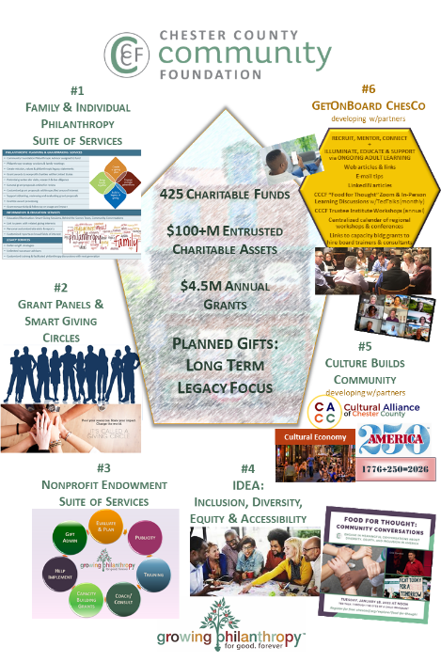
The Community Foundation connects people who care with causes that matter, so their legacies make a difference now and forever. The focus is on endowed assets to benefit the local community for perpetuity. Services are efficiently high-touch and customized, and the long view is emphasized.

Outreach programs to cultivate and inspire legacy philanthropy are key: virtual and in-person grant panels; smart giving circles; family site visits to charities; behind the scenes tours to help donors understand community needs and aspirations; legacy philanthropy profiles and awards; and enhancing linkages to connect legacy donors with volunteer, committee and board service experiences.

Newer programs to grow philanthropy for the long-run include the Cultural Alliance of Chester County/Culture Builds Community; enhanced Inclusion, Diversity, Equity & Accessibility initiatives; and GetOnBoard ChesCo.

Previously, Simmons served for 15 years at LaSalle University's Nonprofit Center in Philadelphia, orchestrating capacity building programs serving nonprofit CEOs and Boards. Under her leadership at LaSalle, the Nonprofit Center grew from a single program with a $75,000 annual budget to a diversified array of nationally recognized programs with a $1.3 million annual operating budget. Simmons is a founding Board member of the Alliance for Nonprofit Management in Washington D.C., which formed as a result of a merger of three national capacity building organizations.

Simmons earned her B.S. at Skidmore College in Saratoga Springs, NY and her M.Ed. at Temple University. She resides in Kennett Square, PA.

Karen A. Simmons
President/CEO
Chester County Community Foundation
28 W. Market Street, The Lincoln Building
West Chester, PA 19382
(610) 696-8845 karen@chescocf.org www.chescocf.org
