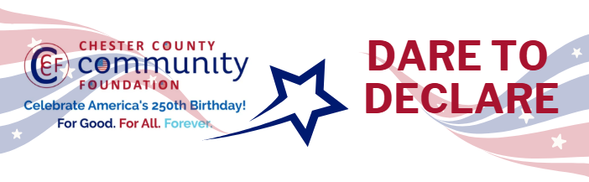

Chester County Community Foundation
“DARE TO DECLARE” MINI-GrANT APPLICATION FORM
An electronic version of this application is available at https://cccf250.org/daretodeclare/
Please note: Per IRS regulations, grants can be awarded to nonprofit charities and municipalities, but NOT individuals nor businesses.
Contact Information
Contact Person Name: James McKinley
Organization Name: Tredyffrin Heritage Center at Duportail
Address: 297 Adams Drive, Chesterbrook, PA 19087
Phone: (445) 241-4427
Email: info@tredyffrinheritagecenter.org
Website: www.tredyffrinheritagecenter.org
Year Incorporated: 2025
FEIN #: 33-4651781
Note: Please attach a copy of your 501c3 letter with this request.

Organization Field of Interest
X | Arts, Culture, Heritage |  | Environment, Animals |  |  | Education, Library
 | Health & Human Services |  | Social Justice, Civil Rights |  |  | Religion
 | Municipality/Govt |  | If other, please describe:

Mini-Grant Amount Requested from the Community Foundation
 | $250 |  | $500 |  | $1,000 |  | $2,000 |  | $2,500 X

Your Dare to Declare Event:
Date  07/04/2026 | Time  12pm-4pm | Location Name  Tredyffrin Heritage Ctr at Duportail | Location Address  297 Adams Drive  Chesterbrook, PA 19087
Please BRIEFLY describe: 1-how this funding will help your Dare to Declare Event, 2-who it will impact, 3-the approximate amount you’ll be spending on Dare to Declare activities overall, and 4-who you are partnering/coordinating with.

Please e-mail this Mini-Grant request with your 501c3 letter to grants@chescocf.org
Dare to Declare Mini-Grant decisions are made on the 25th of each month.
Questions? Contact Grants Officer Stephenie Stevens (610) 696-8211 grants@chescocf.org
For Good. For All. Forever.

The $2,500 requested will support a public Dare to Declare event at the Duportail House on the afternoon of July 4, 2026. The House is an important historic site at the heart of the Chesterbrook community. Funds will be used to rent a sound system, as well as to purchase printed copies of the Declaration of Independence, site information and event materials for the attendees.

American flags will be purchased to hand out to families and children, food trucks will be invited to participate without adding cost to the event and live music offered to create a festive, family-friendly experience. The Declaration itself will be read aloud in a powerful and dynamic way, bringing the founding document to life in one of the actual places where the course of events that led to our independence was charted.

By helping residents understand the role and significance of the Duportail House and surrounding area to the Revolutionary War, the event will build further awareness and support for the Duportail House’s efforts to transform its park-like campus into a key site in Chester County’s Heritage Information Network.

While the event is expected to attract visitors, especially those from the adjacent Valley Forge National Historic Park, it will largely be attended by residents of Chesterbrook and the surrounding area. Many of whom are unaware of the significant role the House and other nearby homes had in the Revolutionary War, especially during the winter encampment of the Continental Army in 1777–78. The event will strengthen their sense of community pride and deepen their connections to our nation’s founding ideals.

The total anticipated cost for the Dare to Declare event is approximately $5,000. This grant along with support from the Duportail House board, individual donors and in-kind contributions are expected to cover its cost. The event will be organized by the Board of Duportail House, which will recruit community members and local leaders to serve as readers and volunteers. Coordination will include outreach to local historical organizations, neighborhood associations, and Chester County’s America250 and Dare to Declare networks to promote participation and attendance.

