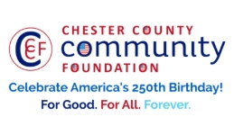
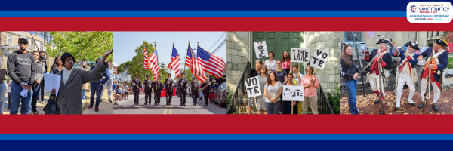

LET FREEDOM RING
AMERICA250 GrANT APPLICATION FORM
Chester County Community Foundation
An electronic version of this application is available at https://cccf250.org/planning/
Contact Information
Contact Person Name: Mary Beth Jackson, Director of Development
Organization Name: French & Pickering Creeks Conservation Trust
Address: Post Office Box 288, Devault, PA 19432
Phone: 610-933-7577, ext. 112
Email: mbjackson@frenchandpickering.org
Website: https://frenchandpickering.org/
Year Incorporated: 1967
FEIN #: 23-6429095
Note: Please attach a copy of your 501c3 letter with this request. Per IRS regulations, grants can be awarded to nonprofit charities and municipalities, but NOT individuals nor businesses.

Organization Field of Interest
 | Arts, Culture, Heritage | x | Environment, Animals |  |  | Education, Library
 | Health & Human Services |  | Social Justice, Civil Rights |  |  | Religion
 | Municipality/Governmental |  | If other, please describe:

A lot | Some | A little
X |  |  | This inspires & engages a wide array of people in commemoration of America’s founding with our Revolutionary Declaration of Independence.
X |  |  | This connects Chester County’s stories to the nation’s past, present & future.
X |  |  | This commemoration is truly by the people, for all people. We invite wide input & welcome all to actively participate.
 |  | x | This examines & fosters fundamental rights of Life, Liberty & the Pursuit of Happiness for All.
x |  |  | We zoom in to CCCF250 planning meetings to share information & ideas.

Amount Requested from the Community Foundation:
 | $250 | x | $1,250 |  | $2,250 |  | $5,000 |  | $10,000

Please BRIEFLY describe how this funding will help your programs, services, activities and/or events to celebrate and commemorate the 250th anniversary of our nation’s Declaration of Independence, and our continuing journey toward liberty and justice for all.
What are you doing? When? Who will it impact? What difference do you aim to make?
What will it cost overall? Who are you partnering & coordinating with?

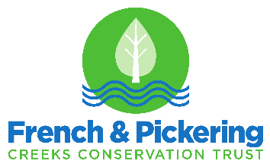

Project Title/Purpose: Historic Cannon Community Outreach & Delivery

Amount Requested: $1,250

What are you doing? Reaching out to local communities, organizations, and businesses and responding to their requests to deliver French & Pickering’s Historic Warwick Furnace Cannon for display at their events. These range from special events, fairs, or festivals, or during a business’ normal hours.

When? Requests for the cannon at local events will be an organizational priority now (February 2026) through July 2026 to promote 250th celebrations. Requests will continue to be reviewed beyond July 2026.

Who will it impact? Chester County residents and visitors, given the significance of the 250th anniversary to our region and country. Chester County businesses that display the cannon will help attract a broader audience throughout the region too.

What difference do you aim to make? To educate members of the public on the contributions the Chester County Iron Industry made regionally and nationally in the 1700s and 1800s, including impacts on the American Revolution.

What will it cost overall? Our cost is $1,278 to cover the expense of transportation and staff time to deliver the cannon on its trailer for each visitation session, plus signage, safety, and trailer registration and protection.

Who are you partnering & coordinating with? Community organizations and businesses, including Historic Yellow Springs, Pottsgrove Manor, Patriot Auto Dealerships, East Goshen Park, Coatesville Area Schools, Exton County Park, and others.

Please e-mail this Mini-Grant request with your 501c3 letter to grants@chescocf.org
Let Freedom Ring Mini-Grant decisions are made on the 25th of each month.
Questions? Contact Grants Officer Stephenie Stevens (610) 696-8211 grants@chescocf.org
For Good. For All. Forever.

