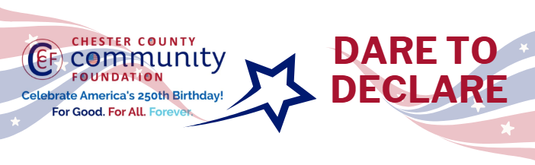

Chester County Community Foundation
“DARE TO DECLARE” MINI-GrANT APPLICATION FORM
An electronic version of this application is available at https://cccf250.org/daretodeclare/
Please note: Per IRS regulations, grants can be awarded to nonprofit charities and municipalities, but NOT individuals nor businesses.
Contact Information
Contact Person Name: Josh Gould
Organization Name: Historical Society of the Phoenixville Area
Address: 204 Church Street, Phoenixville, PA 19460
Phone: 610-952-2255
Email: joshnsu@verizon.net
Website: https://hspa-pa.org https://www.facebook.com/phoenixvillehistory
Year Incorporated: 1977
FEIN #: 23-2125059
Note: Please attach a copy of your 501c3 letter with this request.

Organization Field of Interest
X | Arts, Culture, Heritage |  | Environment, Animals |  |  | Education, Library
 | Health & Human Services |  | Social Justice, Civil Rights |  |  | Religion
 | Municipality/Govt |  | If other, please describe:

Mini-Grant Amount Requested from the Community Foundation
 | $250 |  | $500 |  | $1,000 | X | $2,000 |  | $2,500

Your Dare to Declare Event:
Date  June 13 | Time  12:30 | Location Name  Front Lawn, Historical Society of the Phoenixville Area | Location Address  Corner of Main Street and Church Street (204 Church Street), Phoenixville, PA
Please BRIEFLY describe: 1-how this funding will help your Dare to Declare Event, 2-who it will impact, 3-the approximate amount you’ll be spending on Dare to Declare activities overall, and 4-who you are partnering/coordinating with.

Please see attached.

Please e-mail this Mini-Grant request with your 501c3 letter to grants@chescocf.org
Dare to Declare Mini-Grant decisions are made on the 25th of each month.
Questions? Contact Grants Officer Stephenie Stevens (610) 696-8211 grants@chescocf.org
For Good. For All. Forever.

The Historical Society of the Phoenixville Area is excited to present our Dare to Declare event for America’s 250th anniversary. Our event will include a reading of the Declaration of Independence conducted per the CCCF-provided Guidelines, a large (4’x8’) Declaration for everyone to sign, a Wish Wall where folks are invited to describe their dreams for our country, colonial games and giveaways for children, and giveaways for all ages, including flags and copies of the Declaration.

The HSPA has coordinated with several entities for this project:

- Borough of Phoenixville – it is possible that HSPA’s D2D will be the official Phoenixville D2D
- Schuylkill Township, which is holding its event on an earlier date and will share some purchases to lower our costs, including children’s colonial games
- State Representatives Melissa Shusterman and Paul Friel, whose districts coincide with HSPA’s region (Phoenixville, Schuylkill Twp, East Pikeland Twp, Charlestown Twp, Mont Clare). The Representative’s Offices are providing copies of the DoI and Constitution in English and Spanish.

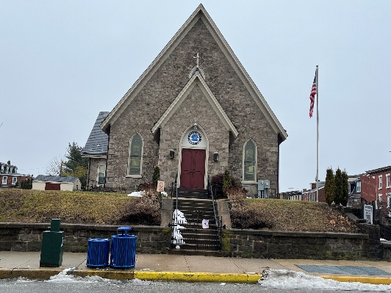
The HSPA expects an excellent turnout of adults and children for our Dare to Declare, which is intended for the general public of all ages. We have chosen to schedule the event for June 13 to coincide with our annual Strawberry Festival, a popular flea market and lunch event that attracted over 500 attendees in 2025. We expect an additional boost in attendance from the Phoenixville Art Street Festival, a closed-street event with approximately 2,000 attendees that reaches nearly to our front door. Both the Strawberry Festival and Phoenixville’s closed-street festivals are popular with all ages and offer games for children.

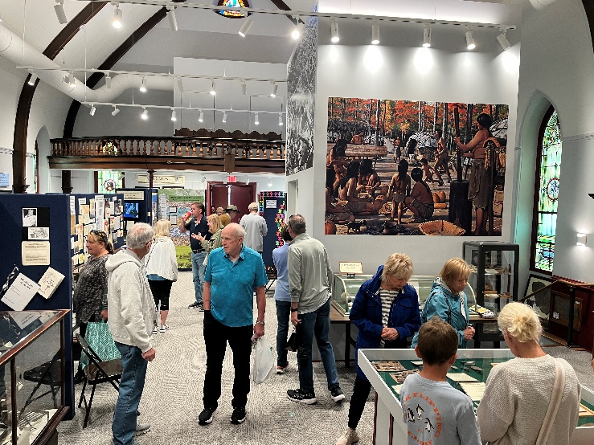
The reading of the Declaration will occur on the front steps of the Society facing Main St (see picture at right), with the readers at the top of the steps so they are visible to the audience. In the event of bad weather, the reading will be moved into the Museum which is now housed in the sanctuary area of the former Central Lutheran church (a portion of the Museum is shown below). Attendees will be invited to enter the Museum following the reading for a group discussion following the guidelines published by CCCF. Before and after the reading there will be reenactors in period dress circulating among the attendees, and some of the reenactors will perform a skit in the Museum. The readers are yet to be determined, but local leaders such as Phoenixville Mayor Peter Urscheler, State Rep. Paul Friel, and State Rep. Melissa Shusterman have been invited and have expressed interest in participating.

CCCF funds will enable us to attract the public to our event and provide meaningful connections to the concepts behind our democracy and the America 250 Celebration. We are requesting $2000 to cover costs associated with the display and attractive giveaways for the public.

Display
2 Feather Flags $300
4-by-8-foot mounted Declaration of Independence poster $200
Wish Wall materials (foam core, printing) $200
Bunting and other appropriate decorations $200

Handout
Color programs $150

Giveaways
200 Feather quill-shaped pens for kids to sign and keep $300
Small American flags $200
Pens printed with HSPA and Am250 CC logos $200
Toy prizes for colonial games $250

Total grant request $2,000

As requested, a copy of our 501c3 letter is attached below.

