Sweet Jane’s Wish
A Fund of the Chester County Community Foundation
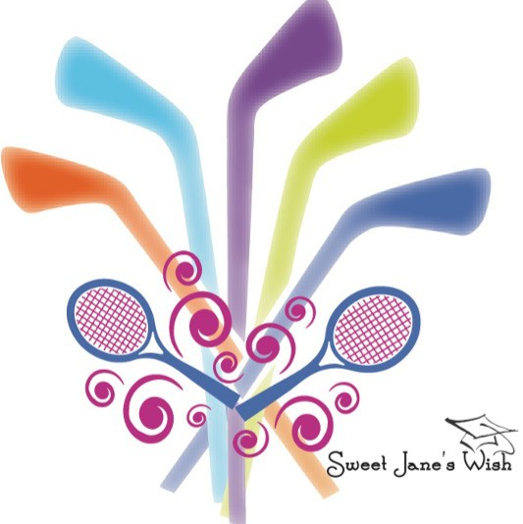
Sweet Jane’s Wish Foundation
Fifteenth Annual Golf Outing, Monday, September 14, 2026

In February 2012, as Jane Gerlach Booge bravely fought breast cancer, her son’s ice hockey team attempted to send her a basket of flowers. However, she graciously declined the offer, asking instead to “use the money for the boys.” Thus, the Sweet Jane’s Wish Foundation was established.
Each year Sweet Jane’s Wish supports various charities in our community. This year’s recipients are Living Beyond Breast Cancer Foundation and the Chester County Hospital Foundation for the SHiNE program. Both of these organizations are dedicated to providing funds to help breast cancer patients who are experiencing the out-of-pocket expenses of fighting this terrible disease. We also award two Ice Hockey Scholarships and two girls’ tennis scholarships to Downingtown East, Downingtown West and Stem High School seniors who will be continuing their education at a college, university or trade school. To date we have distributed $225,000 to these worthwhile causes.
Our event this year will be held at Downingtown Country Club, Downingtown, PA on Monday, September 14, 2026. This is our 15th year of fund raising and we are planning for the biggest event thus far. Registration opens at 10:30 am with a shotgun start at noon. A Box lunch will be provided with and exciting, challenging 18 holes of golf, followed by a cocktail hour, and a sit-down dinner. Live and silent auction are also in the mix. We are currently seeking donations and sponsorship opportunities.

Sweet Jane’s Wish Foundation is a 501(c)3 fund of the Chester County Community Foundation. A copy of the official registration and financial information for the Chester County Community Foundation may be obtained by calling the PA Department of State at 1-800-732-0999.
Registration does not imply endorsement. EIN-23-2773822.

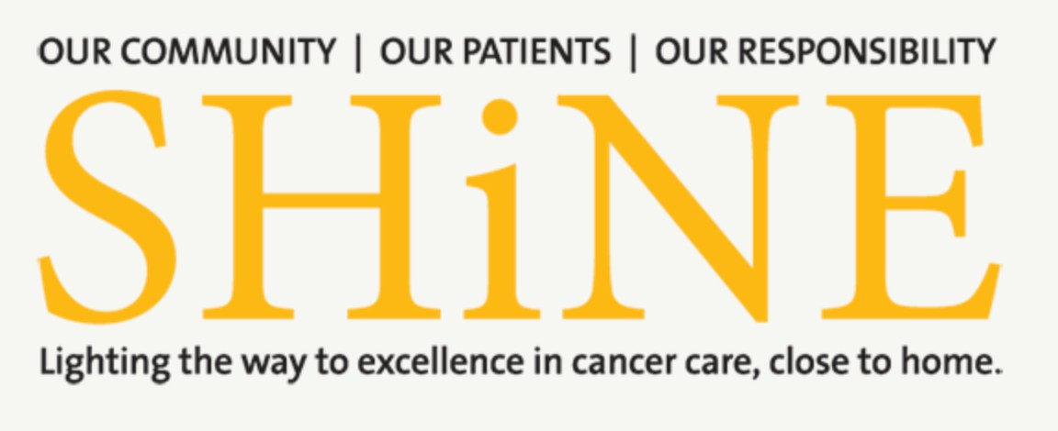
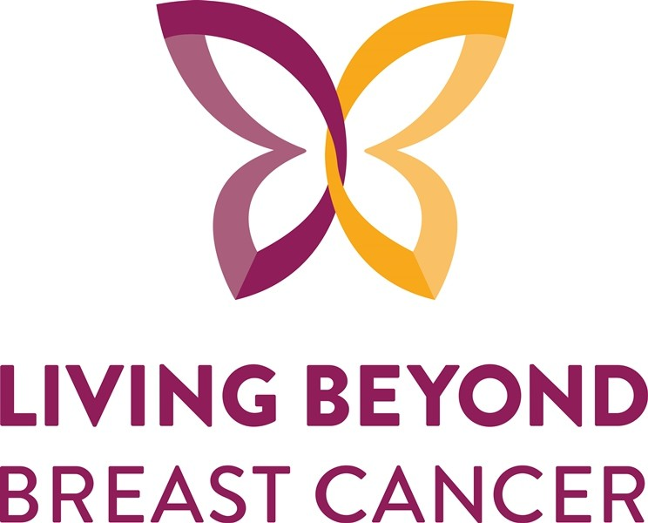
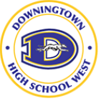
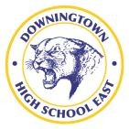
Reserved Seating at VIP Table

$3,000 Presenting Sponsor
Four Golfers, Exclusive Hole Sponsorship,
Full Page Ad in Program, and Social Media Recognition,

$1,250 Gold Sponsor
Four Golfers Exclusive Hole Sponsorship
Full Page Ad in Program & Social Media Recognition

$750 Silver Sponsor
Two Golfers Hole Sponsorship
½ Page Ad in Program & Social Media Recognition

$350 Bronze Sponsor
Hole Sponsorship
½ Page Ad in Program & Social Media Recognition

Organizations We Support

Sponsorship Payment Form

Credit Card Payments Accepted online at: SweetJanesWish.com OR
Mail this page with your payment to:
Chester County Community Foundation Sweet Jane’s Wish Foundation Attn: Paige Marsden 28 West Market, Lincoln Building West Chester PA 19382

Company Name: Address: City, State, Zip: Contact Name and Phone :

Contact Email Address:

If you would like to use your artwork from the previous year, check the box or email your artwork (JPG or PNG format) to Info@SweetJanesWish.com

Name, email and home address of golfers

- name______________________________________email_____________________________________

home address___________________________________________________________________________________

- name__________________________________________ email______________________________________________

home address.__________________________________________________________________________________

- name______________________________________email_____________________________________

home address _____________________________________________________________________

4.name__________________________________email__________________________________

home address______________________________________________________________________

Check one:

$3,000 Presenting Sponsor:
Names of Four Golfers
Artwork: Full Page Ad for Event Program:

$1,250 Gold Sponsor:
Names of Four Golfers
Artwork: Full Page Ad for Event Program
I am not sponsoring but will sign up as individual golfer(s)

I am unable to sponsor but I will donate a raffle basket and/or auction item
Please reach out to JGerlach@AOL.com to coordinate pick up of items

$750 Silver Sponsor:
Names of Two Golfers
Artwork: Half Page Ad for Event Program

$350 Bronze Sponsor:
Artwork: Half Page Ad for Event Program
$50 Dinner & Auction Only

