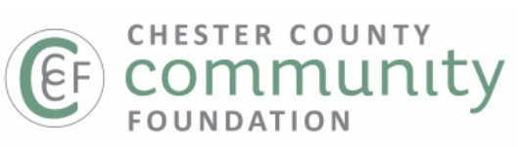
For further information, contact:
Beth Krallis, Marketing, Analytics & IT Director
Chester County Community Foundation
bethk@chescocf.org (484) 887-0467
NEIL JOINES FUND OF CCCF AWARDS OVER $25,000 IN GRANTS

WEST CHESTER, PA – April 22, 2025: The Neil Joines Fund of the Chester County Community Foundation is pleased to award $25,250 in grants to nine organizations for Arts & Culture. The Neil Joines Fund was created in honor of Neil Joines who passed away from pancreatic cancer on November 1, 1992. Joines was passionate about his community and included his philanthropic interests in his will. He stated three purposes of his charitable trust: 1) to expose the Kennett community area to a diverse sample of cultural opportunities, 2) to ensure that piano, art and drama competitions be continued for young people who live in the Kennett Square area, and 3) to support the Kennett Symphony Orchestra.

The following organizations received funding from the Neil Joines Fund of CCCF this year: $3,000 to Brandywine Valley Chorale, $1,500 awarded to Camp Dreamcatcher, $1,500 to Garage Community & Youth Center, $1,500 to Kennett After-School Program, $5,000 to Kennett Area Park Authority, $1,750 to Kennett Library/Bayard Taylor Library, $7,500 to Kennett Symphony, $1,500 to Mighty Writers, and $2,000 to Kennett Flash.

The Neil Joines Fund’s grants reflect the values set forth by Neil Joines himself. The Neil Joines Fund of CCCF has three fund advisors who help Neil’s legacy live on; Jeffrey Darman, Paul Redman, and Scudder Stevens Esq.

To learn more about the Neil Joines Fund of CCCF please visit www.chescocf.org/fund/neil-joines-fund/.

To make a tax deductible donation to the Neil Joines Fund of CCCF, please visit www.chescocf.org/fund/neil-joines-fund/ or send a donation to Neil Joines Fund c/o The Chester County Community Foundation, 28 West Market Street, West Chester, PA 19382.
***
About the Chester County Community Foundation

Headquartered in West Chester’s Lincoln Building, the Chester County Community Foundation connects people who care with causes that matter so their legacy philanthropy makes a difference now and forever. The Community Foundation holds nearly $90 million in trust and annually awards $4.5 million in grants and scholarships. To learn more about the Community Foundation, visit www.chescocf.org.

###

