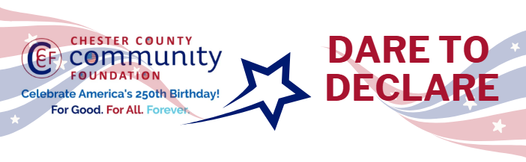

Chester County Community Foundation
“DARE TO DECLARE” MINI-GrANT APPLICATION FORM
An electronic version of this application is available at https://cccf250.org/daretodeclare/
Please note: Per IRS regulations, grants can be awarded to nonprofit charities and municipalities, but NOT individuals nor businesses.
Contact Information
Contact Person Name: Robbyn Kehoe
Organization Name: Atglen Public Library
Address: 121 Main Street, Atglen, PA 19310
Phone: 610-593-6848
Email: rkehoe@ccls.org
Website: https://atglenpubliclibrary.org
Year Incorporated: 1945
FEIN #: 23-2492037
Note: Please attach a copy of your 501c3 letter with this request.

Organization Field of Interest
 | Arts, Culture, Heritage |  | Environment, Animals |  | ☑ | Education, Library
 | Health & Human Services |  | Social Justice, Civil Rights |  |  | Religion
 | Municipality/Govt |  | If other, please describe:

Mini-Grant Amount Requested from the Community Foundation
 | $250 | ☑ | $500 |  | $1,000 |  | $2,000 |  | $2,500

Your Dare to Declare Event:
Date  June 6, 2026 | Time  1:00pm | Location Name  Atglen Public Library | Location Address  121 Main Street  Atglen, PA 19310
Please BRIEFLY describe: 1-how this funding will help your Dare to Declare Event, 2-who it will impact, 3-the approximate amount you’ll be spending on Dare to Declare activities overall, and 4-who you are partnering/coordinating with.
- This funding will provide honoraria for Professors Gimber and Hanley.
- This program will provide an in-depth discussion of the issues underlying the compromises that were ultimately included in the final draft of the Declaration of Independence.
- This is the only program we will be spending on.
- We are coordinating with history professors from West Chester University.
Please e-mail this Mini-Grant request with your 501c3 letter to grants@chescocf.org
Dare to Declare Mini-Grant decisions are made on the 25th of each month.
Questions? Contact Grants Officer Stephenie Stevens (610) 696-8211 grants@chescocf.org
For Good. For All. Forever.

