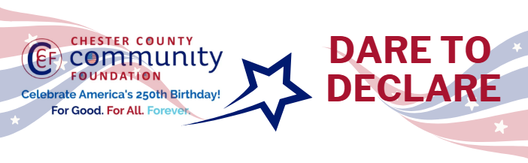

Chester County Community Foundation
“DARE TO DECLARE” MINI-GrANT APPLICATION FORM
Contact Information
Contact Person Name: Tracey Melia & Laurie Scrivens
Organization Name: Chester County Association for the Blind and Visually Impaired
Address: 71 S. 1st Ave Coatesville, PA 19320
Phone: 610-384-2767; 484-459-8742
Email: tracey@chescoblind.org; Laurie.scrivens@verizon.net
Website: CCABVI
Year Incorporated: 1951
FEIN #: 23-1403149
Note: Please attach a copy of your 501c3 letter with this request.

Organization Field of Interest
 | Arts, Culture, Heritage |  | Environment, Animals |  |  | Education, Library
X | Health & Human Services |  | Social Justice, Civil Rights |  |  | Religion
 | Municipality/Govt |  | If other, please describe:

Mini-Grant Amount Requested from the Community Foundation
 | $250 |  | $500 |  | $1,000 |  | $2,000 | X | $2,500

Your Dare to Declare Event:
Date  August 22, 2026 | Time  11am – 5 pm | Location Name  Scouting America,  Chester County Council | Location Address  1 Scouting Way  Exton, PA 19341
Please BRIEFLY describe: 1-how this funding will help your Dare to Declare Event, 2-who it will impact, 3-the approximate amount you’ll be spending on Dare to Declare activities overall, and 4-who you are partnering/coordinating with.

Please e-mail this Mini-Grant request with your 501c3 letter to grants@chescocf.org
Dare to Declare Mini-Grant decisions are made on the 25th of each month.
Questions? Contact Grants Officer Stephenie Stevens (610) 696-8211 grants@chescocf.org
For Good. For All. Forever.

CCABVI: Dare to Declare Expenses: (estimated cost)
1. | Videography - transportation, filming, directing, editing, and presentations (25 readers and their supports) | $ 1,500
2. | Tee shirts (25) | $ 625
3. | Miscellaneous i.e. assistive technology support | $ 375
 | Total | $ 2,500

Date: March 12, 2026
From: Chester County Association for the Blind and Visually Impaired
Re: Let Freedom Ring Grant Request:

How this funding will help your Dare to Declare Event?
The funding will afford us the opportunity to spotlight select individuals in the Chester County area and provide them supports such as speech, assistive technology and guidance to participate in our nation’s 250 celebrations.

Who will it impact?
Individuals with disabilities, their families and the local communities.

The approximate amount will be spending?
An estimate of expenses is attached. Any remaining funds will be a donation to the non-profit for their use at their discretion.

Who are you partnering & coordinating with:
Bored, LLC who brings knowledge of all abilities activities and events.

