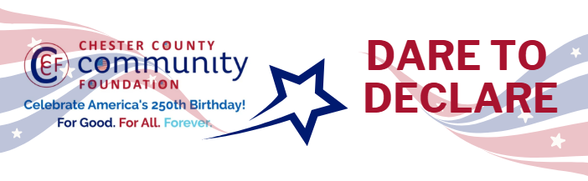

Chester County Community Foundation
“DARE TO DECLARE” MINI-GrANT APPLICATION FORM
An electronic version of this application is available at https://cccf250.org/daretodeclare/
Please note: Per IRS regulations, grants can be awarded to nonprofit charities and municipalities, but NOT individuals nor businesses.
Contact Information
Contact Person Name: Karen Versuk
Organization Name: Penn Township, Chester County
Address: 260 Lewis Road, West Grove, PA 19390
Phone: 610-869-9620
Email: kversuk@penntownship.us
Website: www.penntownship.us
Year Incorporated: 1819
FEIN #: 23-6001516
Note: Please attach a copy of your 501c3 letter with this request.

Organization Field of Interest
 | Arts, Culture, Heritage |  | Environment, Animals |  |  | Education, Library
 | Health & Human Services |  | Social Justice, Civil Rights |  |  | Religion
x | Municipality/Govt |  | If other, please describe:

Mini-Grant Amount Requested from the Community Foundation
x | $250 |  | $500 |  | $1,000 |  | $2,000 |  | $2,500

Your Dare to Declare Event:
Date  August 1, 2026 | Time  2 p.m. to 6 p.m. | Location Name  Penn Township Park | Location Address  260 Lewis Road, West Grove, PA 19390
Please BRIEFLY describe: 1-how this funding will help your Dare to Declare Event, 2-who it will impact, 3-the approximate amount you’ll be spending on Dare to Declare activities overall, and 4-who you are partnering/coordinating with.

This funding will cover the cost of a Dare to Declare 4’ x 6’ banner to be displayed at Penn Township’s “Celebrate our History” weekend August 1 and 2. Attendees will be encouraged to “sign” the banner which will display the entire Declaration of Independence as recognition of the past and affirmation of the future. In addition, reading of the declaration will be done by all ages of our community members, throughout the day in our amphitheater in between musical performances.

Please e-mail this Mini-Grant request with your 501c3 letter to grants@chescocf.org
Dare to Declare Mini-Grant decisions are made on the 25th of each month.
Questions? Contact Grants Officer Stephenie Stevens (610) 696-8211 grants@chescocf.org
For Good. For All. Forever.

