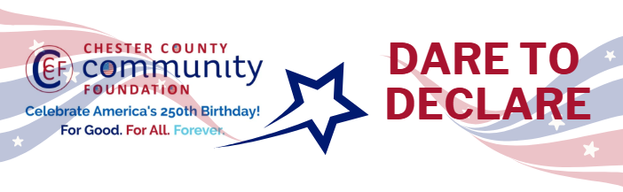

Chester County Community Foundation
“DARE TO DECLARE” MINI-GrANT APPLICATION FORM
An electronic version of this application is available at https://cccf250.org/daretodeclare/
Please note: Per IRS regulations, grants can be awarded to nonprofit charities and municipalities, but NOT individuals nor businesses.
Contact Information
Contact Person Name: Jennifer Spade
Organization Name: Honey Brook Community Library
Address: 687 Compass Rd, Honey Brook, PA 19344
Phone: 610-273-3303
Email: jspade@ccls.org
Website: https://honeybrooklibrary.org/
Year Incorporated:1974
FEIN #:22-2489528
Note: Please attach a copy of your 501c3 letter with this request.

Organization Field of Interest
 | Arts, Culture, Heritage |  | Environment, Animals |  | X | Education, Library
 | Health & Human Services |  | Social Justice, Civil Rights |  |  | Religion
 | Municipality/Govt |  | If other, please describe:

Mini-Grant Amount Requested from the Community Foundation
 | $250 | X | $500 |  | $1,000 |  | $2,000 |  | $2,500

Your Dare to Declare Event:
Date  May 9, 2026 | Time  10 am – 2 pm | Location Name  Honey Brook Community Library | Location Address  687 Compass Rd, Honey Brook, PA 19344
Please BRIEFLY describe: 1-how this funding will help your Dare to Declare Event, 2-who it will impact, 3-the approximate amount you’ll be spending on Dare to Declare activities overall, and 4-who you are partnering/coordinating with.
This $500 mini-grant funding will help with our Dare to Declare event that is planned by allowing us to purchase food, snacks, drinks, paper products, tablecloths, and decorations for our event being held on Saturday, May 9 from 10 - 2 pm at the Honey Brook Community Library. It will also go towards extra staff hours.
Our event is a partnership between the Honey Brook Borough, the Honey Brook Community Library, and the Honey Brook Township Rec and Parks department.
At our event, we will be hosting local Honey Brook organizations and groups in an effort to connect the Honey Brook area community with organizations that are available to join or volunteer with. 15 organizations have been invited to set up a table to speak to members of the community about their organizations and groups. At noon on May 9, we will have a reading of the Declaration of Independence by Senator Katie Muth and Representative Dan Williams. Senator Muth’s office will be bringing pocket US Constitutions to hand out to the community. After the completion of a major renovation and adding additional space, the library is very excited to host this event.

Please e-mail this Mini-Grant request with your 501c3 letter to grants@chescocf.org
Dare to Declare Mini-Grant decisions are made on the 25th of each month.
Questions? Contact Grants Officer Stephenie Stevens (610) 696-8211 grants@chescocf.org
For Good. For All. Forever.

