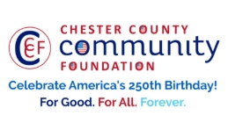
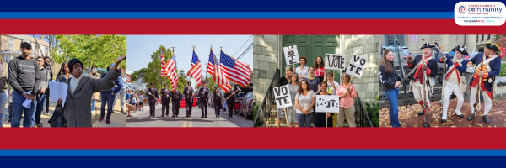

LET FREEDOM RING
AMERICA250 GrANT APPLICATION FORM
Chester County Community Foundation
An electronic version of this application is available at https://cccf250.org/planning/
Contact Information
Contact Person Name: Tracey Melia & Laurie Scrivens
Organization Name: Chester County Association for the Blind and Visually Impaired
Address: 71 S. 1st Ave Coatesville, PA 19320
Phone: 610-384-2767; 484-459-8742
Email tracey@chescoblind.org; Laurie.scrivens@verizon.net
Website: CCABVI
Year Incorporated: 1951
FEIN #: 23-1403149

Organization Field of Interest
 | Arts, Culture, Heritage |  | Environment, Animals |  |  | Education, Library
X | Health & Human Services |  | Social Justice, Civil Rights |  |  | Religion
 | Municipality/Governmental |  | If other, please describe:

A lot | Some | A little
X |  |  | This inspires & engages a wide array of people in commemoration of America’s founding with our Revolutionary Declaration of Independence.
X |  |  | This connects Chester County’s stories to the nation’s past, present & future.
X |  |  | This commemoration is truly by the people, for all people. We invite wide input & welcome all to actively participate.
X |  |  | This examines & fosters fundamental rights of Life, Liberty & the Pursuit of Happiness for All.
 |  | X | We zoom in to CCCF250 planning meetings to share information & ideas.

Amount Requested from the Community Foundation:
 | $250 |  | $1,250 |  | $2,250 |  | $5,000 | X | $10,000

Please BRIEFLY describe how this funding will help your programs, services, activities and/or events to celebrate and commemorate the 250th anniversary of our nation’s Declaration of Independence, and our continuing journey toward liberty and justice for all.
What are you doing? When? Who will it impact? What difference do you aim to make?
What will it cost overall? Who are you partnering & coordinating with?

Please e-mail this Mini-Grant request with your 501c3 letter to grants@chescocf.org
Let Freedom Ring Mini-Grant decisions are made on the 25th of each month.
For Good. For All. Forever.

CCABVI: Let Freedom Ring Estimate of expenses

1. | Public Safety & nurse | $1,000
2. | Food and supplies 200 people | $4,000
3. | DJ music | $600
4. | Game supplies, scavenger hunt, etc. and prizes | $2,000
5. | Insurance | $500
6. | Patriotic Memorabilia Giveaways – American flags, red & blue pens, paper tri-corner hats, ice cream, red, white & blue popsicles. | $700
7. | Rentals & equipment | $2,000
8. | Logo clothing and bags | $2,500
9. | Assistive support | $1,000
10. | Transportation | $500
11. | Miscellaneous | $500
 | Totals | $15,300

Date: March 12, 2026
From: Chester County Association for the Blind and Visually Impaired
Re: Let Freedom Ring Grant Request:

What are you doing?
We are showing a premiere of the filming of a selection of individuals with disabilities and their support’s reading the Declaration of Independence. Additionally, the community will be able to enjoy adapted festive activities and food at the Scouting America facility, Exton Campus.

When?
Saturday, August 22, 2026 from the hours of 11:00 am to 5:00 pm

Who will it impact?
Individuals with disabilities, their families and the local communities.

What difference do you aim to make?
Host an all-abilities event with adapted activities, food and entertainment.

What will it cost overall?
$15,300. Any remaining funds will be a donation to the non-profit for their use at their discretion.

Who are you partnering & coordinating with:
Bored, LLC who brings knowledge of all abilities activities and events.

