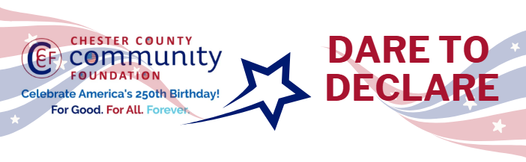

Chester County Community Foundation
“DARE TO DECLARE” MINI-GrANT APPLICATION FORM
An electronic version of this application is available at https://cccf250.org/daretodeclare/
Please note: Per IRS regulations, grants can be awarded to nonprofit charities and municipalities, but NOT individuals nor businesses.
Contact Information
Contact Person Name: James Christ
Organization Name: Paoli Battlefield Preservation Fund
Address: PO Box 173
Phone: 610-476-5310
Email: President@PBPFinc.org
Website: RememberPaoli.org
Year Incorporated: 1999
FEIN #: 23-7843666
Note: Please attach a copy of your 501c3 letter with this request.

Organization Field of Interest
x | Arts, Culture, Heritage |  | Environment, Animals |  |  | Education, Library
 | Health & Human Services |  | Social Justice, Civil Rights |  |  | Religion
 | Municipality/Govt |  | If other, please describe:

Mini-Grant Amount Requested from the Community Foundation
 | $250 |  | $500 |  | $1,000 |  | $2,000 | x | $2,500

Your Dare to Declare Event:
Date  9/26/2026 | Time  11am to 4pm | Location Name  Paoli Battlefield | Location Address  1st Avenue and Wayne Avenue  Malvern, PA 19355
Please BRIEFLY describe: 1-how this funding will help your Dare to Declare Event, 2-who it will impact, 3-the approximate amount you’ll be spending on Dare to Declare activities overall, and 4-who you are partnering/coordinating with.
- Funding will help support renting tents, PA system, advertising and reenactors for our event.
- Anyone who comes to our event will walk away with a better understanding of this important document.
- Will be spending it on this event in 2026,
- In 2027 we will have this event again along with our re-enactment.
- Working with the Paoli Memorial Association and Malvern Borough

For Good. For All. Forever.

