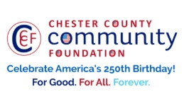
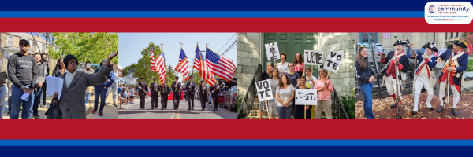

LET FREEDOM RING
AMERICA250 GrANT APPLICATION FORM CCCF
Contact Information
Contact Person Name: Gail Nanjo (Fundraising Chair)
Organization Name: Great Valley Chapter National Society Daughters of the American Revolution
Address: 829 Briarwood Rd - Newtown Square, PA 19073
Phone: 610-883-6746 Email: gsk127@aol.com
Website: https://pssdar.org/chapter_sites/greatvalley.php
Year Incorporated: 1965 FEIN #: 25-6078560

Organization Field of Interest
X | Arts, Culture, Heritage |  | Environment, Animals |  | x | Education, Library
 | Health & Human Services |  | Social Justice, Civil Rights |  |  | Religion
 | Municipality/Governmental | X | If other, please describe: Historic preservation and education

A lot | Some | A little
X |  |  | This inspires & engages a wide array of people in commemoration of America’s founding with our Revolutionary Declaration of Independence.
X |  |  | This connects Chester County’s stories to the nation’s past, present & future.
X |  |  | This commemoration is truly by the people, for all people. We invite wide input & welcome all to actively participate.
 |  | X | This examines & fosters fundamental rights of Life, Liberty & the Pursuit of Happiness for All.
 |  | x | We zoom in to CCCF250 planning meetings to share information & ideas.

Amount Requested from the Community Foundation:
 | $250 | X | $1,250 |  | $2,250 |  | $5,000 |  | $10,000

Great Valley Chapter Daughters of the American Revolution is working with Historic Yellow Springs to place an America250 bronze marker at the site of the Continental Army's first military hospital. This hospital was vital in helping General Washington keep his troops healthy during the winter of 1777-78.

We have received a small grant from DAR but are still trying to find donations and grants to cover the additional $3000 needed to have the bronze plaque made and installed at Historic Yellow Springs. We are planning the unveiling in Summer 2026 to also celebrate the Valley Forge anniversary of the encampment.
###

Project Support
DAR | $ 500 | In-hand
CCCF/250 request | $ 1,250 | pending
IMC Family Foundation | $ 1,000 | pending
Total | $ 2,750
Funding gap | $ 750 | not identified
Project Expenses
Plaque cost | $ 3,300
Installation | $ 200
Total | $ 3,500
Need to raise $3,000 total to complete project.
Budget – HPR 3/19/2026

