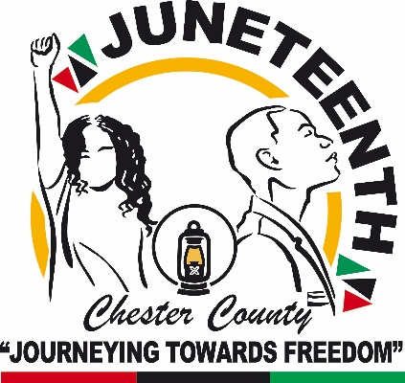
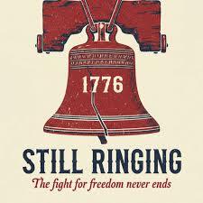
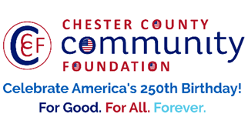



d

Chester County Community Foundation
JuneteentH 2026 FAST-TRACK GrANT APPLICATION FORM
An electronic version of this application is available at https://www.culturechesco.org/juneteenth
Contact Information
Contact Person Name/s: Crystal Crampton and Carol Black
Organization/Fiscal Agent Name: Juneteenth Kennett Square
Address: P.O. Box 1213, Kennett Square PA 19348
Phone: 302-750-1926 for Crystal Crampton and 215-820-1164 for Carol Black
Email:
Website: www.juneteenthkennettsquare.com
Year Incorporated: 2018
FEIN #:
Note: Please attach a copy of your 501c3 letter with this request. Per IRS regulations, grants can be awarded to nonprofit charities and municipalities, but NOT individuals nor businesses.
Organization Field of Interest
x | Arts, Culture, Heritage |  | Environment, Animals |  | x | Education, Library
 | Health & Human Services | x | Social Justice, Civil Rights |  |  | Religion
 | Municipality/Governmental |  | If other, please describe:

A lot | Some | A little
x |  |  | This inspires & engages a wide array of people in commemoration of America’s founding & unfinished business on the path to Liberty & Justice for All.
x |  |  | This connects Chester County’s stories to the nation’s past, present & future.
x |  |  | This commemoration is truly by the people, for all people. We obtain wide input & welcome all to actively participate.
x |  |  | This examines & fosters fundamental rights of Life, Liberty & the Pursuit of Happiness for All.
x |  |  | We zoom in to CCCF Juneteenth &/or CCCF250 planning meetings to share information & ideas.

Estimated Juneteenth Project Budget:
$17,000 | Juneteenth Budget Total
$17,000 | Amount for Juneteenth Activities
$0 ? | Amount for America250 Activities during June & July 2026

Amount Requested from the Community Foundation for Juneteenth + America250 Activities:
 | $500 |  | $1,000 |  | $2,500 |  | $5,000 |  | $7,500 |  | $10,000

Please BRIEFLY describe:
1-How this funding will support your Juneteenth programs, who your Juneteenth attracts & impacts, and who you are partnering/coordinating with. Please describe special challenges or modifications to your ‘typical’ Juneteenth that you are trying to address this year.
This community-focused celebration aims to honor the historical significance of Juneteenth while highlighting the 250-year journey of American history, fostering unity, education, and cultural appreciation within our diverse community. Funding the "Kennett Square Juneteenth Jubilee: Celebrating 250 Years of American History" event will not only honor an important historical milestone but also strengthen community bonds and foster a deeper understanding of our shared heritage. We appreciate your consideration of this proposal and look forward to the possibility of partnering with you to make this event a success.

Objectives:
- Educate attendees about the significance of Juneteenth and its role in American history.
- Celebrate African American culture through music, food, and community engagement.
- Foster a sense of unity and inclusivity among residents.

2-If you are weaving America250/Let Freedom Ring for All activities into Juneteenth 2026, Huzzzzzzah!!! Please briefly describe your plans.
3-Please include your tentative program/activity lineup & estimated budget costs.
Event Details:
- Historical Presentations and Workshops:
Local historical reenactors, historians, storytellers and community speakers will provide engaging presentations and interactive workshops exploring the history of Juneteenth, the story of emancipation, and the holiday’s enduring significance in American history and civic life.
- Music and Spoken Word Performances:

Live performances by stilt walkers, poets, local artists, dancers and drummers will bring vibrant energy to the celebration, showcasing the rich artistic traditions of African and African American cultures through jazz, gospel, soul music, drumming, and spoken-word poetry.

- Children’s Freedom Zone:
Young participants can learn about the meaning of Juneteenth through hands-on arts and crafts activities, such as coloring a Juneteenth flag and making a freedom bracelet. The area will also feature youth drumming circles and opportunities for children to share poetry or spoken word reflections on freedom. A “Freedom Pledge Wall,” where children can write or draw what freedom means to them. They will also enjoy face painting and balloon artists.
- Soul Food and American Refreshments:
A selection of traditional soul food items and diverse American cuisine will be provided to attendees, promoting cultural heritage through culinary experiences.
- Food Trucks:
Local food trucks will be invited to offer a variety of dishes and desserts in celebration of Juneteenth, highlighting culinary traditions associated with African American culture while enhancing the festive community atmosphere.
- Security:
Professional security personnel will ensure a safe and enjoyable environment for all attendees.
- Decorations:
The venue will be adorned with themed decorations that reflect Juneteenth and American history.
- Signage:
Informational signage will be placed throughout the venue to guide attendees and provide educational content.
- Marketing & Promotion:
A marketing campaign will be launched through social media, local newspapers, and community boards to ensure widespread awareness and participation.
- Photography/Videography:

A professional photographer will document the event, capturing moments to share with the community and use for future promotions.

Program Budget:
Budget Item | Description | Amount
Historical Presentations | Honoraria and expenses for historians, reenactors and cultural presenters: 54th Massachusetts Volunteer Infantry Regiment, Daisy Century as Sojourner Truth | $2,000
Music Performances | Fees for stilt walker Mafala Thomas, musicians, drummers, dancers, and sound support | $3,000
Children’s Freedom Zone | Fees for storyteller Bettinita Harris, face painters, balloon artists and art teacher | $1,500
Soul Food Refreshments | Traditional refreshments for community attendees | $2,500
Food Trucks | Vendor stipends to provide additional food options, ice cream, water ice. | $2,500
Security | Event safety personnel and crowd management | $1,000
Decorations | Cultural décor, 10 outdoor tables and 50 chairs, and display materials | $1,500
Signage | Directional signage, banners, and printed event signs | $1,000
Marketing & Promotion | Flyers, social media promotion, advertising, press releases, Eventbrite ticketing, and outreach | $1,000
Photography | Professional photography and documentation | $1,000
Total Project Budget |  | $17,000

This funding will support cultural programming, community engagement, food service, event safety, promotion, and program documentation.

Please e-mail this Mini-Grant request with your 501c3 letter to grants@chescocf.org
Questions? Contact Juneteenth Grants Administrator Paige Mardsen at (610) 696-8211 paige@chescocf.org
For Good. For All. Forever.

