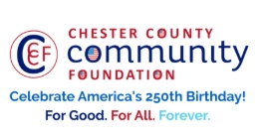
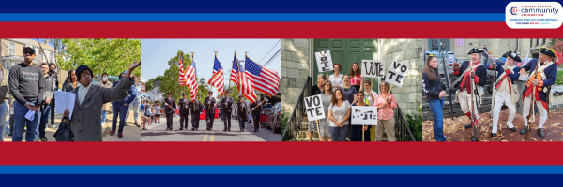

LET FREEDOM RING
AMERICA250 GrANT APPLICATION FORM
Chester County Community Foundation
An electronic version of this application is available at https://cccf250.org/planning/
Contact Information
Contact Person Name: Susan Alloway
Organization Name: Westtown Township Parks and Recreation
Address: 1039 Wilmington Pike, West Chester, PA 19382
Phone: 610-692-1930
Email: salloway@westtown.org
Website: www.westtownpa.org
Year Incorporated: n/a
FEIN #: 23-1633788
Note: Please attach a copy of your 501c3 letter with this request. Per IRS regulations, grants can be awarded to nonprofit charities and municipalities, but NOT individuals nor businesses.

Organization Field of Interest
 | Arts, Culture, Heritage |  | Environment, Animals |  |  | Education, Library
 | Health & Human Services |  | Social Justice, Civil Rights |  |  | Religion
X | Municipality/Governmental |  | If other, please describe:

A lot | Some | A little
X |  |  | This inspires & engages a wide array of people in commemoration of America’s founding with our Revolutionary Declaration of Independence.
X |  |  | This connects Chester County’s stories to the nation’s past, present & future.
X |  |  | This commemoration is truly by the people, for all people. We invite wide input & welcome all to actively participate.
X |  |  | This examines & fosters fundamental rights of Life, Liberty & the Pursuit of Happiness for All.
 | X |  | We zoom in to CCCF250 planning meetings to share information & ideas.

Amount Requested from the Community Foundation:
 | $250 | X | $1,250 |  | $2,250 |  | $5,000 |  | $10,000

Please BRIEFLY describe how this funding will help your programs, services, activities and/or events to celebrate and commemorate the 250th anniversary of our nation’s Declaration of Independence, and our continuing journey toward liberty and justice for all.
What are you doing? When? Who will it impact? What difference do you aim to make?
What will it cost overall? Who are you partnering & coordinating with?

Please e-mail this Mini-Grant request with your 501c3 letter to grants@chescocf.org
Let Freedom Ring Mini-Grant decisions are made on the 25th of each month.
Questions? Contact Grants Officer Stephenie Stevens (610) 696-8211 grants@chescocf.org
For Good. For All. Forever.
Westtown Township Parks and Recreation- Summer Concert Series
Westtown Township Parks and Recreation is seeking funding to support a free Summer Concert Series in celebration of America250, held at the historic Oakbourne Mansion in Oakbourne Park. Set against the mansion’s iconic water tower, the series will connect residents with the township’s rich heritage through live music and shared outdoor experiences. The June 24 Summer Kick-Off Concert will feature Lenape Brass, performing music from significant eras in American history, accompanied by brief educational commentary that highlights each selection’s cultural impact. Additional family-friendly performances by The Sprawlers and The McChords will offer multigenerational entertainment in a welcoming park setting.
Each concert will also include America250-themed children’s crafts, followed by games and activities that promote civic pride and historical awareness. With a total series cost of $1,900, grant funding will directly support performer fees, children’s programming materials, and related expenses. Through this modest investment, Westtown Township Parks and Recreation aims to provide accessible, meaningful programming that celebrates America’s past while strengthening community connections for the future.

