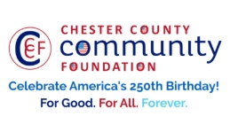
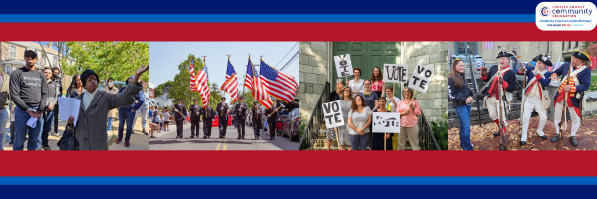

LET FREEDOM RING
AMERICA250 GrANT APPLICATION FORM
Chester County Community Foundation
An electronic version of this application is available at https://cccf250.org/planning/
Contact Information
Contact Person Name: James Christ
Organization Name: Paoli Battlefield Preservation Fund
Address: PO Box 173
Phone: 610-476-5310
Email: President@PBPFInc.org
Website: RememberPaoli.org
Year Incorporated: 1999
FEIN #: 23-7843666
Note: Please attach a copy of your 501c3 letter with this request. Per IRS regulations, grants can be awarded to nonprofit charities and municipalities, but NOT individuals nor businesses.

Organization Field of Interest
x | Arts, Culture, Heritage |  | Environment, Animals |  |  | Education, Library
 | Health & Human Services |  | Social Justice, Civil Rights |  |  | Religion
 | Municipality/Governmental |  | If other, please describe:

A lot | Some | A little
x |  |  | This inspires & engages a wide array of people in commemoration of America’s founding with our Revolutionary Declaration of Independence.
x |  |  | This connects Chester County’s stories to the nation’s past, present & future.
x |  |  | This commemoration is truly by the people, for all people. We invite wide input & welcome all to actively participate.
x |  |  | This examines & fosters fundamental rights of Life, Liberty & the Pursuit of Happiness for All.
x |  |  | We zoom in to CCCF250 planning meetings to share information & ideas.

Amount Requested from the Community Foundation:
 | $250 |  | $1,250 |  | $2,250 |  | $5,000 | x | $10,000

Please BRIEFLY describe how this funding will help your programs, services, activities and/or events to celebrate and commemorate the 250th anniversary of our nation’s Declaration of Independence, and our continuing journey toward liberty and justice for all.
What are you doing? When? Who will it impact? What difference do you aim to make?
What will it cost overall? Who are you partnering & coordinating with?

Heritage Day Saturday, September 18, 2027 (11am to 4pm)

Reenactment Saturday evening September 25, 2027 (4pm to 9pm), Sunday 9/26/2027 from 10am to 2pm)

The funding will help us celebrate the 250th anniversary of the Battle of Paoli, a key battle during the Philadelphia Campaign of 1777.
We have reenactors who will help answer our guests’ questions about what it was like back then.
We have many local historical societies, and many historical sites.
We have authors that have books on this era that can talk to people about what we have learned since then.
We have programs through out the day to teach people what it was like in colonial days.
We wrap up our event with a Solemn wreath laying at the gravesite of 52 fallen soldiers from this battle.

We follow up a week later with a reenactment on the hallowed ground of the Paoli Battlefield.

The next day we will have a morning church service followed by reenactors at stations around the battlefield to inform our guests of what this battle meant and what we have learned since them.

We want everyone who attends these events to understand what happened here 250 years ago and what this did in our history from having the first American battle cry of “Remember Paoli!”, but also the impact it left in the area and on our country as the 9th bloodiest battle of the Revolutionary War.

We will be renting Tents, porta-johns, paying reenactors, marketing, advertising, printing material and tee shirts, and providing supplies for our volunteers, reenactors, and guests for both of these events. They both run between 5-10K per event.

Partnering with the Paoli Memorial Association, Malvern Borough, Continental and British Regiments, and many local volunteers.

Please e-mail this Mini-Grant request with your 501c3 letter to grants@chescocf.org
Let Freedom Ring Mini-Grant decisions are made on the 25th of each month.
Questions? Contact Grants Officer Stephenie Stevens (610) 696-8211 grants@chescocf.org
For Good. For All. Forever.

