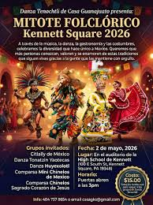
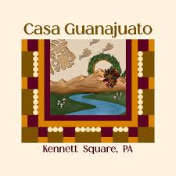

Contact Information
Org: Casa Guanajuato Contact: Kathleen Snyder
Address: E-mail: Ksnyder1948@gmail.com
Phone: Chair: Gonzalo Cano
Website: www.casaguanajuato.org
Year Founded: 2003
EIN: 26-1196055

Which of these Hadley priorities are embedded in your program?
___x__Cultural Enrichment
____x_Diversity/Isms; Bringing Disparate Groups of People Together to Promote Understanding
_____Environmental Justice & Education
___x__Healthy, Sustainable Practices for Individuals and Communities
_____Peace, Justice & Non-Violence

Who do you envision will primarily be attracted to your program? (approximate percentages, please)
___60%___Latinos __15%____Youth
___5%__African Americans ___60%___Families
__25%___White Caucasians ____15%__Seniors
_____General Public ______General Public
___10%___Other: ___10%___Other:
100% Total 100% Total

How many people from the Kennett region will be served by this program?
____less than 25 ____26-100 ____x_101-999 ___over 1,000 ____over 5,000

Personnel
_____ # of Paid Staff _6___ # of Board Volunteers ____20plus____ # of Non-Board Volunteers

Finances
$_____$2,500_____How much grant/sponsorship funding do you seek?
$_____$60,000___What is your overall budget for this year?

1-What is your nonprofit’s mission?
Per our corporate mission, “Appreciation of Mexican culture, art, and traditions and to and commitment to promote and maintain social awareness. “

When we first started there were only Mexicans here but that has changed so we now include not only Mexican but all Hispanic American cultures. Our members, events and entertainment include people from Argentina, native born Americans, Colombians, Guatemalans, and many others.

2-What are you trying to achieve with this program?

Our Celebration of Hispanic Heritage helps people can come together and forget about work and learn something new. Our events are family-oriented with no alcohol. We believe we are breaking the stereotype by showcasing Hispanic arts and crafts and by maintaining our traditions by celebrating typical Hispanic events, so our American-born children (and others) can learn about customs and culture in Mexico and other Latin American countries. This year we will have participation from immigrants from Guatemala, Honduras, Venezuela and others. To know your history is to know yourself.

3- How you will discern the impact and results of this program?
We ask student volunteers to survey the participants so we can better orient our programs to those who follow us.

4- Why is it important to fund this now?
We are shifting our energies to partner at the park with KAPA Kennett Area Park Authority and also Kennett High School. Funds will help with security, police, fire department, musicians, lighting and insurance.

