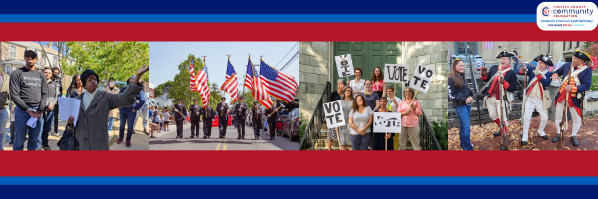
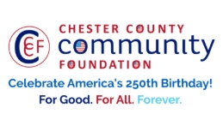

LET FREEDOM RING & DARE TO DECLARE FUNDING REQUEST
AMERICA250 GrANT APPLICATION FORM (as of 4/9/26-Final Funding Requests)
Chester County Community Foundation
An electronic version of this application is available at https://cccf250.org/planning/
Contact Information
Contact Person Name: Lawrence Iaccio
Organization Name: East Whiteland Township
Address: 209 Conestoga Rd. Frazer, PA 19355
Phone: 610-897-4256
Email: Liaccio@eastwhiteland.org
Website: https://www.eastwhiteland.org/
Year Incorporated: N/A
FEIN #: 23-6000322
Note: Please attach a copy of your 501c3 letter with this request. Per IRS regulations, grants can be awarded to nonprofit charities and municipalities, but NOT individuals nor businesses.

Organization Field of Interest
x | Arts, Culture, Heritage |  | Environment, Animals |  |  | Education, Library
 | Health & Human Services |  | Social Justice, Civil Rights |  |  | Religion
x | Municipality/Governmental |  | If other, please describe:

A lot | Some | A little
x |  |  | This inspires & engages a wide array of people in commemoration of America’s founding with our Revolutionary Declaration of Independence.
 | x |  | This connects Chester County’s stories to the nation’s past, present & future.
 | x |  | This commemoration is truly by the people, for all people. We invite wide input & welcome all to actively participate.
 | x |  | This examines & fosters fundamental rights of Life, Liberty & the Pursuit of Happiness for All.
 | x |  | We zoom in to CCCF250 planning meetings to share information & ideas.
Date: | 5/6/2026 |  | We plan to include a Dare to Declare reading of the Declaration of Independence.

Amount Requested from the Community Foundation:
 | $250 |  | $500 |  | $1,250 | x | $2,250 |  | $5,250

Please BRIEFLY describe how this funding will help your programs, services, activities and/or events to celebrate and commemorate the 250th anniversary of our nation’s Declaration of Independence, and our continuing journey toward liberty and justice for all. Include any details about Dare to Declare readings of the Declaration of Independence – especially date/time/place.
What are you doing? When? Who will it impact? What difference do you aim to make?
What will it cost overall? Who are you partnering & coordinating with?

East Whiteland Township Parks & Recreation and Historic Comission in partnership with WHYY will be screening a 1 hour version of Ken Burns recent documentary, The American Revolution. This event will take place at Valley Creek Park (361 N. Morehall Rd. Malvern, PA 19355) on Wednesday 5/6/26 from 7pm – 9pm.

We will have food and beer trucks at the event. The event will kick off with emcee and local historian Jim Segrave-Daly who will introduce the Lenape Brass Quintet who will be playing a selection of Americana/patriotic music. During this hour before the film, we will have the East Whiteland Historic Commission as well as the Chester County Community Foundation present. Jim will then do a public reading of the Declaration and then introduce WHYY and the film. The film will then conclude around 9.

This is a FREE all ages event and based off feedback from our community, is intended to impact everyone. Our intent is to reach audiences of all ages, and instill some national pride while providing an entertaining event.
The overall cost for the event is currently: $2250

Please e-mail this grant request with your 501c3 letter to grants@chescocf.org
Let Freedom Ring & Dare to Declare grant decisions are made weekly.
Questions? Contact Grants Officer Paige Mardsen (610) 696-8211 grants@chescocf.org
For Good. For All. Forever.

