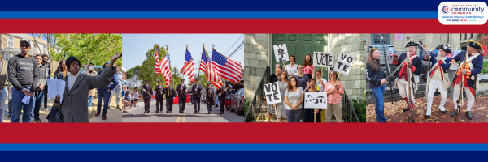
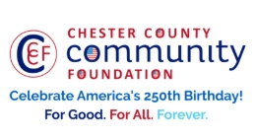

LET FREEDOM RING& DARE TO DECLARE FUNDING REQUEST
AMERICA250 GrANT APPLICATION FORM(as of 4/9/26-Final Funding Requests)
Chester County Community Foundation
An electronic version of this application is available athttps://cccf250.org/planning/
Contact Information
Contact Person Name: Hugo Schmitt
Organization Name: Upper Main Line Memorial Association
Address: PO Box 544, Malvern PA 19355
Phone: 484-883-9837
Email: hugoschmitt37@gmail.com
Website: www.malvernmemorialparade.com
Year Incorporated: first Memorial Parade in 1869
FEIN #:
Note: Please attach a copy of your 501c3 letter with this request. Per IRS regulations, grants can be awarded to nonprofit charities and municipalities, but NOT individuals nor businesses.

OrganizationField of Interest
X | Arts, Culture, Heritage |  | Environment, Animals |  |  | Education, Library
 | Health & Human Services |  | Social Justice, Civil Rights |  |  | Religion
 | Municipality/Governmental |  | If other, please describe:

A lot | Some | A little
X |  |  | This inspires & engages a wide array of people in commemoration of America’s foundingwith our Revolutionary Declaration of Independence.
 | X |  | This connects Chester County’s stories to the nation’s past, present & future.
X |  |  | This commemoration is truly by the people, for all people. We invite wide input & welcome all to actively participate.
 |  | X | This examines & fosters fundamental rights of Life, Liberty & the Pursuit of Happiness for All.
 | X |  | We zoom in to CCCF250 planning meetings to share information & ideas.
Date: | 5/31/2026 |  | We plan to include a Dare to Declare reading of the Declaration of Independence.

Amount Requested from the Community Foundation:
 | $250 |  | $500 | X | $1,250 | X | $2,250 |  | $5,250

PleaseBRIEFLYdescribehow this funding will help your programs, services, activities and/or events to celebrate and commemorate the 250thanniversary of our nation’s Declaration of Independence, and our continuing journey toward liberty and justice for all. Include any details about Dare to Declare readings of the Declaration of Independence – especially date/time/place.
What are you doing? When? Who will it impact? What difference do you aim to make?
What will it cost overall? Who are you partnering & coordinating with?

Please e-mail this grant request with your 501c3 letter to grants@chescocf.org
Let Freedom Ring& Dare to Declaregrant decisions are made weekly.
Questions? Contact Grants Officer Paige Mardsen (610) 696-8211 grants@chescocf.org
For Good. For All. Forever.

The Upper Main Line Memorial Association has been hosting the Malvern Memorial Parade for several decades, a "Sunday-after-Memorial Day" tradition dating back to 1869. In conjunction with the 250th birthday of the US, we would like to include a reading/recitation of the Declaration of Independence following our parade and as a part of our commemoration ceremony held at the Paoli Memorial Grounds (404 Monument Ave, Malvern PA 19355) on Sunday, May 31, 2026. The parade steps off at the Malvern Fire House (424 E King St) at 1:30pm marching west to Warren Ave, south on Warren Ave to Monument Ave, and west again to the Paoli Memorial Grounds. The more sombre ceremony includes an invocation, taps, and more. This is where we will add local Malvernites reading the Declaration of Independence as part of the event.
This parade is one of the oldest in the US, tied with other locations such as Ironton, OH. Ours sometimes gets overlooked as it does not take place on Memorial Day (the 4th Monday in May), and rarely occurred on May 31 when the holiday was called Decoration Day on that static date. We have over 30 groups participating as well as at least 5 bands marching in this parade and are still finalizing the 2026 participants.
This parade celebrates our military (both those that returned home as well as those that gave their lives for us), our first responders (police and fire), and our local community groups and volunteers that make our slice of America great. The remembrance ceremony following allows us to reflect on our past and look ahead to great things. A cakewalk following the ceremony aims to be a fun family event as well.
The impact the parade makes is our community as a whole. We remind participants and the 2000+ witnesses of the sacrifices our foreparents made for us. If you've never attended, please attend and enjoy seeing the dozens of homes along the parade route with the annual lawn parties, hosting friends and family who return annually for this celebration.
Our board has fewer than a dozen members, all volunteers. We do coordinate with the Borough of Malvern the Malvern Police to block the roads and help traffic move along, but the planning and execution is ours alone.
We rely on the donations of citizens and local businesses. The cost of our 2025 parade was just over $10,300, but we wanted to make the 2026 parade larger and more special with at least one extra family event and more participants! What better way to celebrate the 250th? In addition to the inclusion of the Declaration reading, we're contacting 2-3 more bands ($1500-$2500 each), and we are doing a cakewalk as a special event for this year which is another band cost and needs supplies such as cakes for prizes and tables to hold the cakes. With more persons expected to attend we will have more programs to print, too. We are sourcing American flags to hand out to parade goers and something as simple as bottled water for participants and organizers would also go a long way. Any amount of grant would be an incredible help.

