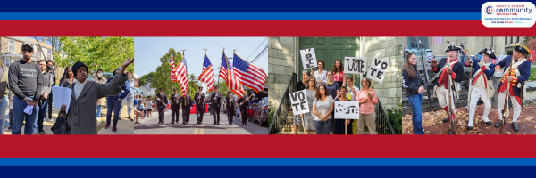
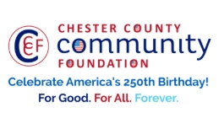

LET FREEDOM RING & DARE TO DECLARE FUNDING REQUEST
AMERICA250 GrANT APPLICATION FORM (as of 4/9/26-Final Funding Requests)
Chester County Community Foundation
An electronic version of this application is available at https://cccf250.org/planning/
Contact Information
Contact Person Name: Cindy Abbadini
Organization Name: American Legion Post 491
Address: 208 E. State St. Kennett Square, PA 19348
Phone: 410-903-3454
Email: cjapsu85@gmail.com
Website:
Year Incorporated: 1920
FEIN #: 23-6438645
Note: Please attach a copy of your 501c3 letter with this request. Per IRS regulations, grants can be awarded to nonprofit charities and municipalities, but NOT individuals nor businesses.

Organization Field of Interest
 | Arts, Culture, Heritage |  | Environment, Animals |  |  | Education, Library
 | Health & Human Services |  | Social Justice, Civil Rights |  |  | Religion
 | Municipality/Governmental | x | If other, please describe: Veteran Service Organization

A lot | Some | A little
x |  |  | This inspires & engages a wide array of people in commemoration of America’s founding with our Revolutionary Declaration of Independence.
 | x |  | This connects Chester County’s stories to the nation’s past, present & future.
 | x |  | This commemoration is truly by the people, for all people. We invite wide input & welcome all to actively participate.
 | x |  | This examines & fosters fundamental rights of Life, Liberty & the Pursuit of Happiness for All.
 | x |  | We zoom in to CCCF250 planning meetings to share information & ideas.
Date: | 25 Jul |  | We plan to include a Dare to Declare reading of the Declaration of Independence.

Amount Requested from the Community Foundation:
 | $250 |  | $500 | x | $1,500 |  | $2,250

Please BRIEFLY describe how this funding will help your programs, services, activities and/or events to celebrate and commemorate the 250th anniversary of our nation’s Declaration of Independence, and our continuing journey toward liberty and justice for all. Include any details about Dare to Declare readings of the Declaration of Independence – especially date/time/place.
What are you doing? When? Who will it impact? What difference do you aim to make?
What will it cost overall? Who are you partnering & coordinating with?

Please e-mail this grant request with your 501c3 letter to grants@chescocf.org
Let Freedom Ring & Dare to Declare grant decisions are made weekly.
Questions? Contact Grants Officer Paige Mardsen (610) 696-8211 grants@chescocf.org
For Good. For All. Forever.

Throughout the summer, American Legion plans on doing several events related to celebrating America 250.

American Legion Post 491 plans on doing a Wish Wall in conjunction with Kennett Square’s June Third Thursday event. Our goal is to attract families and children from Kennett and the surrounding area. We also hope to attract local veterans from the surrounding community to see the American Legion and learn more about the benefits of membership.

In collaboration with the William Taylor Sea Cadets, we also plan to do a Dare to Declare Event. This reading would incorporate members of American Legion Post 491 along with members of the Sea Cadets. This is scheduled for 25 July at Mount America.

American Legion Post 491, in conjunction with the Kennett Library is sponsoring a Boston Tea Party themed puppet show on 6 August. After the puppet show, children will be asked to participate in a short debate as either a patriot or a loyalist. The people who put on the puppet show are experienced reenactors who charge a fee for the event.

We expect to spend approximately $1500 on all our events.

