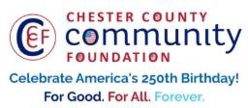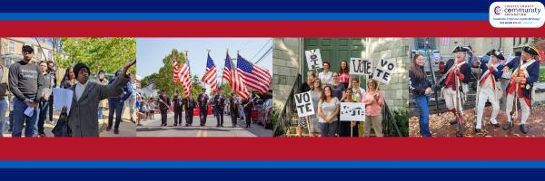

LET FREEDOM RING & DARE TO DECLARE FUNDING REQUEST
AMERICA250 GRANT APPLICATION FORM (AS OF 4/9/26-FINAL FUNDING REQUESTS)
CHESTER COUNTY COMMUNITY FOUNDATION
Contact Information
Kelly Donia & Larry Iaccio
Contact Person Name:
Organization Name:
East Whiteland Township - Historical Commission
East Whiteland Township Building, 209 Conestoga Road, Frazer, PA 19355
Address:
Phone:
610-517-1329
Email: liaccio@eastwhiteland.org
kelly@doniadesigns.com
Website:
www.eastwhiteland.org
1765
Year Incorporated:
FEIN #:
Note: Please attach a copy of your 501c3 letter with this request. Per IRS regulations, grants can be awarded to nonprofit charities and municipalities, but NOT individuals nor businesses.
Organization Field of Interest
X
X
 | Arts, Culture, Heritage |  | Environment, Animals |  | Education, Library  X
 | Health & Human Services |  | Social Justice, Civil Rights |  | Religion
 | Municipality/Governmental |  | If other, please describe:

A lot | Some | A little
 |  |  | This inspires & engages a wide array of people in commemoration of America’s founding with our Revolutionary Declaration of Independence.
 |  |  | This connects Chester County’s stories to the nation’s past, present & future.
This commemoration is truly by the people, for all people. We invite wide input & welcome all
to actively participate.
 |  |  | This examines & fosters fundamental rights of Life, Liberty & the Pursuit of Happiness for All.
 |  |  | We zoom in to CCCF250 planning meetings to share information & ideas.
Date: |  |  | We plan to include a Dare to Declare reading of the Declaration of Independence.
Amount Requested from the Community Foundation:
X
X
X
 | $250 |  | $500 |  | $1,250 |  | $2,250  X |  | $5,250
Please BRIEFLY describe how this funding will help your programs, services, activities and/or events to celebrate and commemorate the 250th anniversary of our nation’s Declaration of Independence, and our continuing journey toward liberty and justice for all. Include any details about Dare to Declare readings of the Declaration of Independence – especially date/time/place.
What are you doing? When? Who will it impact? What difference do you aim to make? What will it cost overall? Who are you partnering & coordinating with?

Please e-mail this grant request with your 501c3 letter to grants@chescocf.org Let Freedom Ring & Dare to Declare grant decisions are made weekly.
Questions? Contact Grants Officer Paige Mardsen (610) 696-8211 grants@chescocf.org
For Good. For All. Forever.

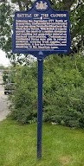
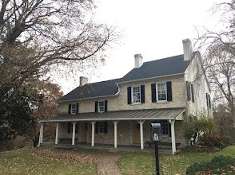
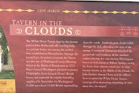

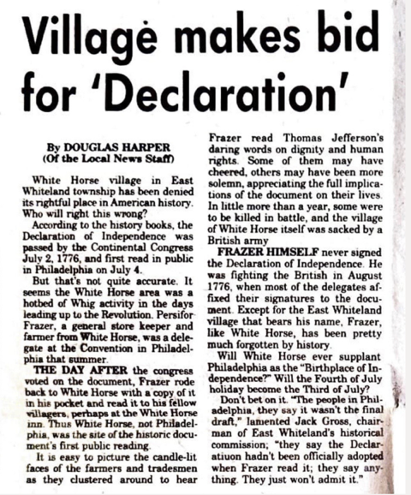

Good Morning!

My name is Kelly Donia and I am a member of East Whiteland Township's Historical Commission.
We are holding a Dare to Declare Event on 7/5 from 5:30PM to 7:30 PM.

Our mission is to educate both young and old of how our area played a significant role in the American Revolution and that the people both Nationally and Locally famous had great things to do with giving us the country and township we all enjoy today. We will also connect this with how each of us can also be civically responsible and continue to protect democracy and freedoms for us all.

It will be held at the Village of Whitehorse as it was called in those days with the Whitehorse Tavern being the center of the activities. (606 East Swedesford Road, Malvern, PA) https://www.whitehorsetavern.org

It will include:

Renactors (Washington, Jefferson, Persifer Frazer, and both Loyalist and Patriot Towns People all stationed about the event and at the White Horse Tavern.

Tours of the tavern as well as other historical properties in the village will be offered.

Contest for the best colonial garb with a prize of a gift card to the General Warren Inn

Refreshments

Facepainting

Balloons

Centennial flags and copies of the Declaration of Independence

Music

All Culminating with a reading of the Declaration of Independence in front of the historic White Horse Tavern.

Signage for the event will include a large copy of the Declaration of Independence that all will be able to sign.

We will also be posting the Preamble as well as another graphic showing the list of grievances against the King.

Thank you for your help with this event!

