Sweet Jane’s Wish Foundation Awards Scholarships to Downingtown East and West Ice Hockey Players

Downingtown, PA—April 22nd— Sweet Jane’s Wish (SJW) Foundation is happy to announce that Seniors, Brody Meyers, of Downingtown West and Grace O’Donnell, of Downingtown East have been selected as the winners of the annual SJW scholarship fund. Four students are selected each school year from the tennis and ice hockey teams by the SJW Foundation. Brody and Grace join our Fall scholarship recipients, Lola Roberts and Kanakvi Pulekar. SJW Foundation is a fund of the Chester County Community Foundation and honors the memory of Jane Gerlach Booge who tragically lost her battle with breast cancer at age 47. Jane attended Downingtown High School and was a member of the tennis team. Her quiet confidence and positive attitude took her to numerous championship matches including districts and state competitions. Jane was well known for her compassion and friendship to many.
SJW Foundation honors students such as Brody and Grace who share Jane’s qualities of determination, resilience, camaraderie and have a love of tennis or ice hockey. Brody and Grace demonstrate these qualities by consistent dedication to their sport and team members.
Imagine trying to learn a new sport in eighth grade. Imagine having to learn to ice skate at the same time while competing with others who have been doing both for years. That’s exactly what Brody Meyer did. He had played travel soccer since second grade and wanted a new challenge. Hockey required a whole new skill set, and he worked hard at building those skills. When he didn’t make the varsity team junior year, he was disappointed. Brody said, “I had two choices; accept being comfortable where I was or push myself to improve.” He chose to work hard and examine every aspect of the sport to improve his game. He realized that he would need to “outwork doubt and disappointment”. Hockey taught Brody to set goals, be diligent, and to never give up. Hockey also showed him the importance of supporting his teammates and in setting a good example and thereby contributing to the overall success of the team. Brody’s coach, Brett Mackell said, “Brody constantly shows up. He always has a positive attitude with his teammates and others regardless of what is going on that day and is always open to coaching.”
For Grace O’Donnell, being on the ice was a refuge. It was a place where she could focus on just playing ice hockey and being part of a team. It was a place where everything else fell away. Ice hockey allowed her to feel successful and more importantly that she was not alone. Grace, despite adversity in her life and perhaps because of those challenges, found solace in playing hockey. Hockey helped her to focus on something she enjoyed and excelled at. It became an outlet for her and a reminder that there was something to look forward to beyond her difficulties. Many people focus inward during difficult times, but Grace found peace and hope in thinking about ice hockey and the love, support and sense of belonging that her team provided. Her dedication to her team was evident as she always gave her best to the game and her teammates. Per Grace’s coach, John Hyland, “Grace is a standout both on and off the ice. She consistently goes above and beyond and sets a tone of responsibility and commitment that others naturally follow.” Grace wrote, “Hockey taught me that setbacks do not define me, but how I respond does.” Life is a series of challenges. Each designed to teach us something about ourselves to help us to grow. Grace’s perspective will serve her well.
Brody and Grace are talented ice hockey players who are passionate about the game. It’s clear that the game is just a part of what they have learned along the way. Both are leaders and their enthusiasm for the game is evident. They’ve learned to work hard and never give up. These lessons have developed skills and character which will serve them throughout their lives.
We are honored to have Brody and Grace join the forty-eight previous recipients of this $6,500 award. To date SJW Foundation has awarded $196,950 in scholarships to Downingtown East and West High School Seniors who have participated in the student tennis and ice hockey programs and are furthering their education at a University, College, or Trade School.
Due to the success of the annual golf outing and the amazing generosity of supporters, the SJW Foundation is also able to support the Living Beyond Breast Cancer (LBBC) organization and the Chester County Hospital Foundation, SHiNE with a yearly donation. The SJW Foundation has donated more than $37,500 to support local families experiencing financial crisis, due to the additional costs not covered by traditional insurance, while fighting breast cancer.
SJW Foundation scholarships are funded by an annual golf outing, dinner, and auction and by generous donations from our community. Please join us on Monday, September 14, 2026, for our 15th annual golf outing. The outing will be held at the Downingtown Country Club, in Downingtown, PA. Please look online for more information at www.sweetjaneswish.com and follow us on Facebook. We hope you join us for a wonderful day that supports our community!
For more information, press only:
Alexandra Grigson
(484) 919-5699
Agrigson@gmail.com
For more information on the Sweet Jane’s Wish Foundation:
www.sweetjaneswish.com and follow us on Facebook.
Downingtown West Picture from left:
Parent, Eric Meyer, scholarship recipient, Brody Meyer, parent, Kristy Meyer
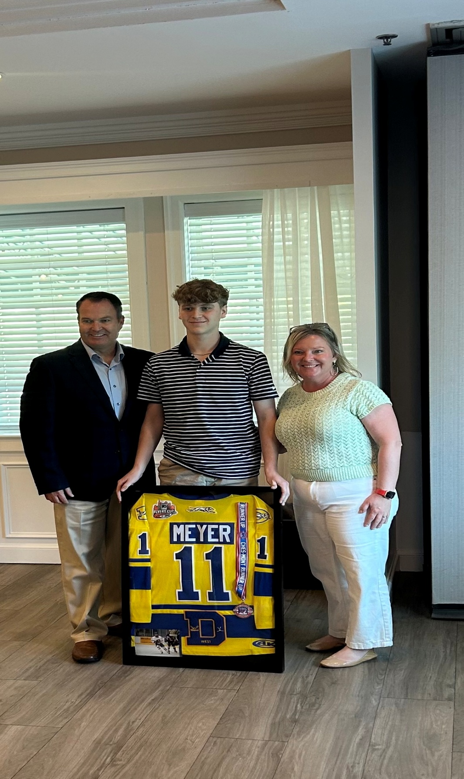
Downingtown East Picture from left:
Parent, Amber Shook, scholarship recipient, Grace O’Donnell, Coach, John Hyland
